Imperial College London

Department of Earth Science and Engineering

MSc in Applied Computational Science and Engineering

Independent Research Project – ACSE 9

Final Report

**Financial Security Price Prediction with Deep Learning**

By Jack Quested

jack.quested20@imperial.ac.uk

GitHub ID: acse-jaq15

GitHub Repo: <https://github.com/acse-2020/acse2020-acse9-finalreport-acse-jaq15>

Supervisor: Dr. Cedric John

Co-Supervisor: Prof. Stephen Neethling

June 2021

**Abstract**

A comparative study between Deep Learning architectures and their ability to perform univariate time series forecasting was undertaken. Financial time series data from 2014 - 2019 was used, with the period 2014 - 2018 forming the training dataset and 2019 being the test dataset. Models were tasked with predicting the next day’s closing price based upon the preceding 30 days of closing prices. 12 models were used, including LSTM, GRU, CNN and MLP based architectures. 12 securities were examined, drawing from each of the major financial asset classes: commodities, currencies, equities and fixed income. Each model was used on each security and underwent hyperparameter tuning. Model predictions were assessed via error metrics: MSE, RMSE and MAE. The loss function used by all models was the MSE of the prediction. A dummy model was used as a control against which predictions were also assessed. The dummy model returned the arithmetic mean of the 30 day window as its prediction. A points system was used to rank all models according to the MSE of their predictions. The same system was used to rank all securities based on how difficult models found them to predict. All models performed better than the dummy model, with GRU based models performing the best. LSTM based models performed marginally worse than GRUs, while CNN based architectures were the worst performers. GRU and LSTM based models performed substantially better than all others. Hyperparameter tuning results across models suggested that SELU was the most appropriate activation function, followed by tanh. Similarly, the most regularly used optimisers were Adam and nAdam, while SGD and RMSprop resulted in notably worse performance by comparison. Fixed income securities generated the lowest mean squared errors, whilst commodities produced the highest. Inverse correlation between the volatility of a security and the models ability to predict accurately was found. The number of trainable parameters was found to have minimal influence over the accuracy of a models predictions.

***Key words: deep learning, financial time series, univariate time series analysis, price prediction, GRU, LSTM***

**Acknowledgements**

I would like to thank my supervisor Dr Cedric John for his helpful guidance with this project. Thanks are also owed to Marijan Beg for his input and help as leader of the study group and to the ACSE faculty for delivering the course in a highly unusual and difficult environment. Gratitude is extended to my employer, the UK Debt Management Office, for allowing me to take a sabbatical in order to undertake this degree. Finally, I would like to thank my friends and family for their support in a year of challenges.

**Introduction**

For as long as there have been financial securities, market participants have sought methods to forecast prices (Galbraith, 1955). A major riposte to this practice came in 1970 with the publication of the Efficient Market Hypothesis (EMH) (Malkiel & Fama, 1970). The EMH posited that stocks and, by wider extension, financial securities (Malkiel, 1973), follow a random walk, making consistently accurate forecasting virtually impossible.

Advances in computational hardware, and the adoption of mathematical models, led some investors from the late 1980’s onwards to achieve success (Ziemba, 2020; Harding, 1994). These quantitatively focused methods of investment were unorthodox (Malkiel, 1973) and would only gain wider acceptance from the mid 2000’s (Lewis, 2014; Lo, 2017). David Harding and Jim Simons are early notable examples of investors adopting such an approach in a successful manner (Harding, 1994; Ziemba, 2020).

The advent of Deep Learning (DL), and the advances it has wrought, now means that an active area of research is in financial time series prediction using DL (Sezer, Gudelek & Ozbayoglu, 2020).

Financial time series are known to be non-linear, and as such are difficult to predict (Rezaei, Faaljou & Mansourfar, 2021; Jayanth, Harish Ram & Nair, 2018). However, this has not deterred researchers: numerous statistical, Machine Learning (ML) and DL based forecasting approaches exist (Sezer, Gudelek & Ozbayoglu, 2020).

Some researchers approached the problem by studying only ML approaches (Bontempi, Taieb & le Borgne, 2013), while others adopted a purely DL based method (Sezer, Gudelek & Ozbayoglu, 2020).

It has been found that some ML based approaches perform no better, or marginally worse, than statistical implementations (Cao, Leggio & Schniederjans, 2005). Conversely, DL is at the forefront of current research, with DL implementations now outperforming ML and statistical approaches (Sezer, Gudelek & Ozbayoglu, 2020; Hiransha *et al.*, 2018).

The computerisation of financial markets has led to a dearth of data being available. This, combined with the development of automated trading systems, has led to a surge in the number of research articles focusing on DL and financial time series analysis, as noted in Fig. 1.

*Figure 1. Histogram of the number of published papers on DL applications in financial time series analysis since 2009* (Sezer, Gudelek & Ozbayoglu, 2020)

What precisely makes DL perform so well is an area of active research and debate. In general terms, it is understood that DL makes use of the unknown structure of the input distribution in order to discover representations of the data (Bengio, 2012) - though it is noted that DL architectures are prone to overfitting and computational complexity. Various regularisation mechanisms exist to combat the former, whilst newer, more efficient, architectures can combat the latter (Bengio, Boulanger-Lewandowski & Pascanu, 2013; Dahl, Sainath & Hinton, 2013).

Early advances in DL came from the use of a Deep Multi-Layer Perceptron (MLP) (Goodfellow, Bengio & Courville, 2016), where the network has fully connected input, hidden and output layers, with each neuron using a non-linear activation function (Goodfellow, Bengio & Courville, 2016). MLP networks have been successfully used in classification and regression type problems (Gardner & Dorling, 1998).

Though MLPs represented a significant step forward, they were not without issues. The use of fully connected layers causes computational complexity considerations, while MLP networks are also susceptible to vanishing gradients (Sezer, Gudelek & Ozbayoglu, 2020; Gardner & Dorling, 1998).

Recurrent neural networks (RNN) are another approach that use internal memory to interpret inputs, thus making them well suited to sequenced data such as time series (Deng & Yu, 2014). RNNs themselves make use of backwards temporal dependence (Rumelhart, Hinton & Williams, 1986). However, when learned knowledge is stored for too long, continuing to train the network becomes difficult (Pascanu, Mikolov & Bengio, 2013).

Long Short-Term Memory (LSTM) networks are a subtype of RNNs that have come to dominate the field of financial time series analysis (Sezer, Gudelek & Ozbayoglu, 2020). LSTMs were first introduced in 1997 (Hochreiter & Schmidhuber, 1997) and were subsequently refined in 1999 with the addition of forget gates (Gers, Schmidhuber & Cummins, 1999). The use of an LSTM can go some way towards ameliorating the drawbacks of RNNs (Sezer, Gudelek & Ozbayoglu, 2020).

A Gated Recurrent Unit (GRU) is a network type that has been found to be performant in handling time series (Chung *et al.*, 2014). Similar to an LSTM, it lacks an output gate and may represent an efficient choice in time series analysis.

Convolutional Neural Networks (CNN) are a type of DL network commonly used in computer vision applications. They have also been used effectively in analysing financial time series where the use of kernel filters allows for computationally efficient implementations (Sezer, Gudelek & Ozbayoglu, 2020).

Autoencoders (AE) have been demonstrated to be of use in time series analysis (Sezer, Gudelek & Ozbayoglu, 2020). AEs effectively remap the features of the input data in such a way that the remapped data are representative of structures that can be used for classification (Hinton & Salakhutdinov, 2006). It is noted that AE feature extraction can struggle with highly dimensional data (Meng *et al.*, 2017).

There has also been an increasing volume of research into the specific topic of DL applications within financial time series analysis. This can generally be divided into 2 main areas of research: price prediction and trend prediction. The former attempts to forecast the actual price within a given window (and the focus of this project) and the latter simply tries to predict whether the market will rise, fall or remain neutral (Sezer, Gudelek & Ozbayoglu, 2020).

The asset class most frequently examined in the literature is that of equities, followed by foreign exchange and commodities. Fixed income remains a field with a far smaller body of research (Sezer, Gudelek & Ozbayoglu, 2020).

The models mentioned in this discussion have all been selected for inclusion in this study. All the chosen models have a wide and established research base (Sezer, Gudelek & Ozbayoglu, 2020) and either have been, or are currently, state of the art. Thus, the model selection is representative of what is most widely accepted to be the forefront of research in DL based time series analysis. Much of the literature discussed looks at individual DL architectures without broad based comparisons to other network types. From this, much of the motivation to conduct to a comparative study stems.

See Appendix 1 for a table of the models implemented. For detailed graphic representation of the exact model architectures used, please refer to the [model_graphs](https://github.com/acse-2020/acse2020-acse9-finalreport-acse-jaq15/tree/main/model_graphs) directory in the GitHub repo. A detailed explanation of the model architectures is beyond the remit of this comparative study. A large body of relevant literature exists in which architectural features of the models are discussed at length.

Securities used in this study were selected so as to adequately represent the 4 major financial asset classes; commodities, currencies, equities and fixed income (Graham, Dodd & Buffett, 2009). The securities themselves are liquid and have reliable historical price data which can be noted from Appendix 2.

The prices that form the historical data are daily closing prices, calculated at the end of a trading day, from the first trading day of 2014 till the final trading day of 2019. Each security has a differing number trading days in a year, depending on the trading calendar of the listing jurisdiction.

The methodologies for arriving at these closing prices can vary from security to security. For those securities listed on an exchange, the exchange operator publishes detailed information on the process. Some securities (currencies and US Treasuries) are not listed on an exchange and are traded in over the counter (OTC) markets. For currencies, the specific data vendor, in this case Bloomberg LP, has their own methodology for the calculation of closing prices. These are commonly based on London trading hours as it is the world centre of currency trading (Hull J, 2012). Exactly how the closing prices are determined is largely inconsequential to this study, but further details can be obtained via the documents published by said exchange operators or data vendors.

The loss function used in the optimisation of all models was the mean squared error (MSE) of predictions. Other error metrics used in addition to MSE were root mean squared error (RMSE) and mean absolute error (MAE) where:

$$MSE= \frac{1}{n}\sum_{i=1}^{n}{{(Y_{i}-{\hat{Y}}_{i})}^{2}}$$

$$RMSE= \sqrt{\frac{1}{n}\sum_{i=1}^{n}{{(Y_{i}-{\hat{Y}}_{i})}^{2}}}$$

$$MAE= \frac{\sum_{i=1}^{n}{\left|Y_{i}-{\hat{Y}}_{i}\right|}}{n}$$

With $n$ being the number of data points and $Y_{i}-{\hat{Y}}_{i}$ being the difference between the true and predicted value.

|  |  |  |  |  |  |  |  |  |
| --- | --- | --- | --- | --- | --- | --- | --- | --- |
| **Model** | **Activation**  **Function** | **Batch Size** | **Epochs** | **Dropout** | **Input Layer Size** | **Hidden Layer Size** | **Learning Rate** | **Optimiser** |
| CNN | SELU, RELU | 32, 64, 128 | 50, 100, 200 | - | - | - | 0.005, 0.001, 0.0005 | Adam, nAdam, RMSprop |
| CNN GRU | SELU, RELU | 32, 64, 128 | 50, 100, 200 | - | - | - | 0.005, 0.001, 0.0005 | Adam, nAdam, RMSprop, SGD |
| CNN LSTM | SELU, RELU | 32, 64, 128 | 50, 100, 200 | - | - | - | 0.005, 0.001, 0.0005 | Adam, nAdam, RMSprop, SGD |
| GRU | tanh, SELU, RELU | 32, 64, 128 | 50, 100, 200 | 0.2, 0.3, 0.4 | 25, 50, 100 | 25, 50, 100 | 0.005, 0.001, 0.0005 | Adam, nAdam, SGD |
| GRU AE | tanh, RELU | 32, 64, 128 | 50, 100, 200 | 0.1, 0.2, 0.3 | - | - | 0.005, 0.001, 0.0005 | Adam, nAdam, RMSprop |
| GRU LSTM | tanh, RELU, SELU | 32, 64, 128 | 50, 100, 200 | - | - | - | 0.005, 0.001, 0.0005 | Adam, nAdam, RMSprop |
| LSTM | tanh | 32, 64, 128 | 50, 100, 200 | 0.2, 0.3, 0.4 | 25, 50, 100 | 25, 50, 100 | 0.005, 0.001, 0.0005 | Adam, nAdam, RMSprop |
| LSTM AE | tanh, RELU | 32, 64, 128 | 50, 100, 200 | 0.1, 0.2, 0.3 | - | - | 0.005, 0.001, 0.0005 | Adam, nAdam, RMSprop |
| LSTM GRU | tanh, RELU, SELU | 32, 64, 128 | 50, 100, 200 | 0.1, 0.2, 0.3 | - | - | 0.005, 0.001, 0.0005 | Adam, nAdam, RMSprop |
| MLP | RELU, SELU | 32, 64, 128 | 50, 100, 200 | - | - | - | 0.005, 0.001, 0.0005 | Adam, nAdam, RMSprop, SGD |
| MLP AE | RELU, SELU | 32, 64, 128 | 50, 100, 200 | - | - | - | 0.005, 0.001, 0.0005 | Adam, nAdam, RMSprop, SGD |

*Table 1. Model hyperparameters included in tuning*

A number of activation functions were included in hyperparameter tuning: RELU, SELU and tanh, where tanh is the hyperbolic tangent. RELU and SELU are expanded below:

$RELU(x)=max⁡(0, x)$ (Fukushima, 1980)

$SELU\left(x\right)=λ\left\{\begin{aligned}x, &x<0 \\ αe^{x}-α, &x≥0\end{aligned}\right.$ (Klambauer *et al.*, 2017)

All models implemented used a degree of dropout, either 0.1, 0.2 or 0.3. For some models, this was included in the hyperparameter search, for others a dropout value of 0.1 was used with no tuning. This was done in order to limit the size of the hyperparameter tuning sweeps in order to facilitate completion within a feasible timeframe. Please refer to Table 1 for more details, where no entry is found, dropout was 0.1.

**Software Description and Methodology**

The study was performed by following a workflow, see Fig. 2, where each model was used to make predictions for each security. The workflow was performed in a Google Colaboratory notebook.



*Figure 2. Model workflow*

First the data was loaded via a call to the Data_Reader class, then separated into training, validation and test datasets. The training dataset forms the time period 2014 - 2018, with the test dataset consisting of the data from 2019. The validation dataset, used to perform hyperparameter tuning, spans the date range 2014 - 2018, with 2014 - 2017 being the validation training set and 2018 the validation test set.

Using the same Data_Reader class, X and y datasets were extracted. The X dataset is used by the model to makes predictions, which were evaluated against the extracted y dataset. This was performed for the training, testing and validation datasets. The X and y datasets are made up of normalised data. Data is normalised via (0,1) min/max feature scaling, where:

$$x^{'}=\frac{x-min⁡(X)}{\max\left(X\right)-min⁡(X)}$$

With $x^{'}$ being the normalised value of original value $x$, where $x∈X$, with $X$ being the entire unnormalised dataset.

Hyperparameter tuning was then conducted with Weights and Biases (wandb) integration, wandb is a service that performs hyperparameter tuning, among other ML related tasks. Table 1 shows the hyperparameters for which each model was tuned. Tuning was conducted on the validation dataset, making use of the respective validation training and test datasets.

Tuning took place using a random search methodology in order to discover potentially more powerful settings earlier than if conducting a grid search (Bergstra & Bengio, 2012). Hyperparameter tuning continued until certain stopping criteria were reached. Provided the loss was below a certain threshold, and had ceased to change by a certain degree, searching was terminated. Across all searches a total of 5,347 different model combinations were tested on the validation set. See Fig. 3 for an example visualisation of a wandb search run and how different parameters influence the loss function.



*Figure 3. Visualisation of hyperparameter searching with wandb*

Following the completion of hyperparameter tuning, optimal settings were then used to create a model that was trained for the number of epochs specified by the search. This model was then tested on the test dataset and assessed using the error metrics. A diagrammatic representation of the model and a plot of predicted and actual prices were then saved to memory.

The GPU typically used when connected to Google Colaboratory was an Nvidia Tesla P100 Server Graphics Card. Where model architectures permitted, this GPU allowed for Nvidia’s CUDA Deep Neural Network parallel programming platform to be enabled, lowering hyperparameter tuning and model training times.

**Code metadata**

The language used in this study was Python 3.2.10, Python has seen widespread adoption among the DL community (Sezer, Gudelek & Ozbayoglu, 2020) and a wide variety of useful packages and languages are available. One such library is Keras which runs on top of Google’s well known TensorFlow. The Keras version used was 2.6.0 and was selected due to the ease of constructing DL architectures. This library contains many DL architectural units that run out of the box such as LSTM, GRU and CNN layers. Scikit-Learn (SK Learn) was used to perform normalisation of price data, the version used was 0.22.2.

Pandas 1.1.5 was used for handling data and storing model evaluation data. Under the hood data manipulation performed by multiple modules, discussed later, used NumPy version 1.19.5. Testing within the GitHub repo was done using PyTest version 3.6.4 and plotting handled by Matplotlib version 3.2.2. The operating system used was macOS version 11.4.

**Implementation and Code Description**

In order to facilitate the previously mentioned workflow, a number of modules were implemented, these included the data_reader, base_model and model_loader modules.

The data_reader module contains a Data_Reader class and was used to manipulate the time series data prior to being fed through a model. The class takes in two positional arguments: a string and an integer. The string defines which security will have its data loaded, the integer denotes what data from the time series will form the test dataset. For all use cases in this study, the integer argument was always 2019, meaning the test dataset comprised all closing price data from that year.

Instantiation of the Data_Reader class creates various other attributes, which are added to as additional class methods are called. These methods must be called in the correct order or else an error is returned. The first method to be called is .extract_train_test, which generates training and test datasets, both normalised and unnormalised. Unnormalised datasets are retained as class attributes, despite the additional memory overheads, so as to facilitate plotting of real prices once predictions have been made.

The Data_Reader class also generates X and y variables for all datasets via a call to .extract_xy method. This method takes in two positional arguments, the window length and a Boolean that determines the dimensions of the resulting X arrays. The window length variable tells the Data_Reader class the number of preceding days of closing prices upon which the single day ahead prediction will be based. For all use cases in this study the window length was 30, meaning the model based its predictions on the previous 30 days of closing price data.

Where the Boolean is set to False, the resulting X arrays have a number of columns equal to the window length, in this case 30, and a number of rows equalling the number of days in the dataset, minus the window length. When this Boolean is set to True, the X arrays have a modified shape. This allows for convolutional model architectures to process the data. Models that required this Boolean to be set to True were CNN GRU and CNN LSTM.

The base_model module contains the Base_Model class. This class acts as a control against which DL predictions can be judged. The Base_Model class takes the preceding day’s closing prices and returns the mean of that period as its prediction. In some cases, partly due to overfitting, or use of models with inadequate depth, some ML and DL models were found to generate predictions no better than the mean (Cao, Leggio & Schniederjans, 2005). The use of this class as a control therefore allows a low hurdle against which the DL models can be compared.

The model_loader module contains Trained_Model and Untrained_Model classes. These classes are used for demonstration purposes and in the evaluation of the finalised models. The Trained_Model class can be used to load saved models. These saved models are hyperparameter optimised models that were used in this study to generate predictions. The trained models have weights and biases generated from training as per the relevant Colaboratory notebook.

The Untrained_Model class loads untrained models that carry the default settings used prior to hyperparameter tuning. These models have randomly initialised weights and biases, done so according to the Keras documentation.

An additional consideration is the use of a separate GitHub repo from which these modules are loaded in the Colaboratory notebooks. A public repo named feeder_repo was used to allow for safe reproducibility of the notebooks by an independent user. A number of constraints and issues informed the decision to use this dual repo design. One such issue was the security concerns raised by attempting to access a private repo via the notebook. In order to do this, private SSH keys or GitHub usernames and passwords must be saved as variables within the notebook. These concerns were addressed by using the public feeder_repo to clone into the notebook environment. The feeder_repo was populated with the relevant modules and data by manually adding them from the private GitHub repo used for this study. Use of GitHub’s repo mirroring was not possible since a private repo cannot be mirrored by a public one.

**Results, Discussion and Conclusions**

The models were judged using a ranking system based on the MSE of their predictions. For each security, the models were sorted in ascending order according to the MSE of their prediction. The 12 models were then awarded points according to their rank, with the lowest MSE model receiving a rank of 1st and 1 point respectively, whilst the model with the highest MSE was given a rank of 12th and 12 points. This scoring was applied to all model and security combinations and the total points used to give a final ranking. The model with the lowest number of points was ranked 1st, see Table 2.

|  |  |  |
| --- | --- | --- |
| **Model** | **Points** | **Rank** |
| GRU_LSTM | 36 | 1 |
| LSTM_GRU | 38 | 2 |
| GRU | 41 | 3 |
| GRU_AE | 45 | 4 |
| LSTM_AE | 72 | 5 |
| MLP | 75 | 6 |
| LSTM | 76 | 7 |
| CNN | 77 | 8 |
| MLP_AE | 86 | 9 |
| CNN_GRU | 123 | 10 |
| CNN_LSTM | 123 | 11 |
| Dummy | 144 | 12 |

*Table 2. Model rankings, sorted by rank*

The model that achieved the best ranking was GRU LSTM, while 2 points behind that in 2nd place was LSTM GRU. All models beat the dummy model, which ranked 12th overall and for each individual security. The joint worst performing DL models were the CNN GRU and CNN LSTM models.

The CNN family of models: CNN, CNN GRU and CNN LSTM, were some of the worst performing models, generating the highest cumulative MSE scores and occupying positions 8, 10 and 11. The GRU family of models: GRU, GRU AE, GRU LSTM, returned some of the best scores, occupying ranks 1st, 3rd and 4th.

Close grouping at the top of the ranking table occurred. The top 4 positions all fell within a 9 point range of each other, starting at 36 points for 1st and 45 points for 4th. There was a notable jump of 27 points between 4th and 5th, LSTM AE coming in at 5th with 72 points against the 45 point score of GRU AE in 4th.

The lowest MSE overall was achieved by the GRU AE model on the Bund 10y security, with an MSE of 0.000926. The highest overall MSE achieved by a non-dummy model was MLP AE predicting Amazon prices, with an MSE of 0.00884.

The same ranking methodology was applied to every security in order to gauge each securities influence over the MSE. The securities that had the lowest cumulative MSEs were Bund 10y and Treasury 10y with 19 points each. The security that generated the highest MSEs were aluminium futures with 131 points, see Table 3.

|  |  |  |
| --- | --- | --- |
| **Security** | **Points** | **Rank** |
| Bund10y | 19 | 1 |
| Treasury  10y | 19 | 2 |
| Gilt10y | 44 | 3 |
| Nvidia | 47 | 4 |
| EURCHF | 70 | 5 |
| Amazon | 82 | 6 |
| Google | 90 | 7 |
| GBPUSD | 92 | 8 |
| EURUSD | 98 | 9 |
| Cu | 115 | 10 |
| Corn | 129 | 11 |
| Al | 131 | 12 |

*Table 3. Security rankings, sorted by rank*

It can be noted that commodities generated the highest MSEs across models, with the 3 securities from this asset class occupying the lowest 3 rankings. The inverse is true of fixed income, where the 3 government bonds, Bund 10y, Treasury 10y and Gilt 10y, occupied the top 3 positions with the lowest cumulative scores.

The volatility of each security was recorded, see Appendix 3. Table 4 shows the correlation between the volatility and the number of cumulative points scored by each security. Some degree of inverse correlation occurs between the number of points and the volatility of the whole, training and test datasets. The security with the highest volatility, Bund 10y, ranked 1st as the security with the lowest cumulative score.

|  |  |  |  |  |
| --- | --- | --- | --- | --- |
|  | **Whole Dataset & Points** | **Train Dataset & Points** | **Test Dataset & Points** | **Train/Test Ratio & Points** |
| **Correlation** | -55.40% | -55.83% | -52.35% | 34.05% |

*Table 4. Volatility correlation with cumulative points*

Table 5 shows which hyperparameters were most commonly used by the optimal models. SELU was the most regularly used activation function, whilst RELU was by far the least used option. This suggests that the self-normalising nature of SELU (Klambauer *et al.*, 2017) provides a performance benefit when considering time series data with DL architectures.

The most used optimiser by the final models was Adam, whilst a batch size of 32 was preferred to a similar degree. Learning rate choices were the most evenly distributed of hyperparameters.

It should be noted that for some models, SGD was an optimiser included in the hyperparameter search, though none of the best search results returned this choice. This indicates that for time series analysis: Adam and nAdam represent a significant improvement. In addition, RMSprop seems ill-suited to this type of problem, being used only 9 times.

|  |  |  |
| --- | --- | --- |
| **Hyperparameter** | | **Use Count** |
| Activation Function | SELU | 65 |
| tanh | 52 |
| RELU | 15 |
|  |  |  |
| Optimiser | Adam | 89 |
| nAdam | 34 |
| RMSprop | 9 |
|  |  |  |
| Batch Size | 32 | 80 |
| 64 | 38 |
| 128 | 14 |
|  |  |  |
| Learning Rate | 0.001 | 49 |
| 0.005 | 45 |
| 0.0005 | 38 |

*Table 5. Most commonly used hyperparameters*

As noted from Table 6 the number of trainable parameters displays positive correlation with the number of points scored. The CNN hybrid models: CNN LSTM and CNN GRU, had a much larger average number of trainable parameters than other models, yet were the worst performing models. The comparative magnitude of these models average trainable parameters should be noted. When CNN LSTM and CNN GRU are ignored as outliers, the correlation drops to a mere 14%.

|  |  |  |
| --- | --- | --- |
|  | **With Outliers** | **Without Outliers** |
| **Correlation** | 80.10% | 14.44% |

*Table 6. Trainable parameter correlation with cumulative points*

An additional extension exercise was undertaken where the prediction length of the model was increased from 1 day to 15 days, with one prediction for each day. The output vector of the model was changed from a vector with a single element to a vector with 15 elements. As noted from Table 7, there is strong correlation between each of the models 1 day and 15 day MSE, RMSE and MAE values.

|  |  |  |  |
| --- | --- | --- | --- |
|  | **MSE** | **MAE** | **RMSE** |
| **Correlation** | 83.09% | 78.20% | 90.00% |

*Table 7. Correlation between 1 day and 15 day error metrics*

A number of points must be considered before drawing conclusions. A limiting factor in this study was the focus on univariate price prediction. There is heavy correlation between security prices and certain economic factors, either as leading or lagging indicators (Graham, Dodd & Buffett, 2009). These factors may improve the performance of the models to a varying degree depending on architecture, yet these relationships are untouched by this study.

Intraday price moves are one of the major contributing factors to a securities closing price (Taleb, 1997). More specifically, large standard deviation price moves in the first half of the trading day are more likely than not to be sustained into the market close (Taleb, 2004), and as such heavily influence the closing price. These moves are not captured or examined by this study.

The limited scope of the extension exercise is additionally noted. The use of best performing models means limited conclusions can be inferred, poorly performing models may perform better at predicting 15 day windows than 1 day windows. This was not investigated as they were omitted from the exercise.

Furthermore, with 12 securities used in this study, though drawing from each of the major asset classes, the sample size is small compared to the large universe of potential securities. This results in a constrained ability to extrapolate conclusions beyond those securities that have been examined.

Moreover, the timeframe in which the study was conducted limited the length of time that could be dedicated to hyperparameter tuning. It is noted that hyperparameter tuning was relatively constrained in approach when compared to studies that focus on single model architectures (Sezer, Gudelek & Ozbayoglu, 2020).

The small size of the training dataset is another consideration. With roughly 1250 individual data points and being only ~5x larger than the test dataset, some models examined may benefit from a larger training period and improve their resulting performance.

What can be concluded is that GRUs are the most powerful models used in this study and represent a significant improvement on LSTMs from which they are derived. LSTM based models still perform strongly, being second only to GRU based models in the ranking system. LSTM and GRU hybrid models occupy the top 2 positions and represent powerful choices for researchers in this field.

CNNs struggle in this limited instance of univariate time series prediction. This may be due to the large number of parameters used requiring longer training periods and being prone to overfitting. Ignoring CNNs, it can be inferred that the number of trainable parameters has little bearing on the performance of a model, what is more important is the nature of the architectural features of the model.

According to the results of hyperparameter tuning, SELU and tanh represent compelling choices of activation functions when considering time series data. On a similar basis, Adam and nAdam are the optimisers that performed most strongly. They represent meaningful performance improvements when compared to RMSprop and SGD, which seem inappropriate choices for DL architectures applied to time series data.

The volatility of the time series being analysed somewhat explains a models ability to deliver accurate predictions. The higher the volatility, the lower the MSE is likely to be. This suggests there is an underlying relationship between the volatility of the security and the models ability to predict 1 day ahead prices, albeit in a counterintuitive inverse manner.

A models ability to predict 1 day ahead prices is not necessarily indicative of its ability to predict 15 days ahead due to the limited size of the extension exercise. Aside from that, it should be noted that the error metrics in the models used were heavily correlated between their 1 and 15 day ahead values.

There are a number of areas that may form the body of future research. A wider choice of hyperparameters may result in the discovery of new performant parameter combinations. Deeper models, that take longer to train, may return improved results when compared to the relatively short time available to train models used in this study. A wider comparison between a models ability to predict 1 and 15 day ahead prices may reveal interesting findings about certain architectures. In addition, the expansion to multivariate time series analysis would be the next logical step based upon the results of this study.

**Appendicies**

Appendix 1: Models used and associated abbreviations

|  |  |
| --- | --- |
| **Model Name** | **Abbreviation** |
| Convolutional Neural Network | CNN |
| Convolutional Neural Network with Gated Recurrent Units | CNN GRU |
| Convolutional Neural Network with Long Short-Term Memory Units | CNN LSTM |
| Stacked Gated Recurrent Unit Neural Network | GRU |
| Stacked Gated Recurrent Unit Neural Network Autoencoder | GRU AE |
| Stacked Gated Recurrent Unit Neural Network with Long Short-Term Memory Units | GRU LSTM |
| Stacked Long Short-Term Memory Unit Neural Network | LSTM |
| Stacked Long Short-Term Memory Unit Neural Network Autoencoder | LSTM AE |
| Stacked Long Short-Term Memory Unit Neural Network with Gated Recurrent Units | LSTM GRU |
| Multi-Layer Perceptron Neural Network | MLP |
| Multi-Layer Perceptron Neural Network Auoencoder | MLP AE |

Appendix 2: Securities and associated details

|  |  |  |  |  |  |
| --- | --- | --- | --- | --- | --- |
| **Abbreviation** | **Security** | **Description** | **Exchange** | **Country** | **Units** |
| Al | 3 month aluminium futures | Physically settled aluminium futures, for delivery in 3 months | LME | UK | USD/mt |
| Corn | Rolling active month corn futures | Physically settled corn futures, rolling active contract | CME | USA | USd/bushel |
| Cu | 3 month copper futures | Physically settled copper futures, for delivery in 3 months | LME | UK | USD/mt |
| EURCHF | Euro / Swiss Franc spot exchange rate | Currency pair for settlement in 2 business days | OTC | Eurozone & Switzerland | - |
| EURUSD | Euro / United States Dollar spot exchange rate | Currency pair for settlement in 2 business days | OTC | Eurozone & USA | - |
| GBPUSD | British Pound / Euro spot exchange rate | Currency pair for settlement in 2 business days | OTC | UK & USA | - |
| Gilt10y | Rolling 10y British Gilt yield | The yield of rolling 10y Gilt | LSE/OTC | UK | % |
| Bund10y | Rolling 10y German Bund yield | The yield of the rolling 10y Bund | FSE/OTC | Germany | % |
| Treasury10y | Rollitn 10y United States Treasury yield | The yield of the rolling 10y Treasury | OTC | USA | % |
| Amazon | Amazon.com Inc. common stock | The stock price of Amazon | NASDAQ | USA | USD/share |
| Google | Alphabet Inc. class A common stock | The stock price of Alphabet | NASDAQ | USA | USD/share |
| Nvidia | NVIDIA Corporation common stock | The stock price of Nvidia | NASDAQ | USA | USD/share |

Appendix 3: Security volatilities and cumulative points, sorted by whole dataset volatility

|  |  |  |  |  |  |
| --- | --- | --- | --- | --- | --- |
| **Security** | **Whole**  **Dataset**  **Volatility** | **Train**  **Dataset**  **Volatility** | **Test Dataset Volatility** | **Train/Test**  **Ratio** | **Points** |
| Bund10y | 4.235148 | 3.637762 | 9.861522 | 0.368884 | 19 |
| Gilt10y | 0.600167 | 0.52237 | 0.895036 | 0.58363 | 44 |
| Nvidia | 0.405764 | 0.404163 | 0.414818 | 0.974314 | 47 |
| Treasury10y | 0.324428 | 0.317194 | 0.359283 | 0.882852 | 19 |
| Amazon | 0.301493 | 0.313541 | 0.23195 | 1.351765 | 82 |
| Google | 0.236191 | 0.235455 | 0.240532 | 0.978891 | 90 |
| Al | 0.185155 | 0.192454 | 0.142202 | 1.353382 | 131 |
| Cu | 0.172372 | 0.178017 | 0.138755 | 1.282964 | 115 |
| EURCHF | 0.091292 | 0.098694 | 0.036389 | 2.712219 | 70 |
| GBPUSD | 0.084042 | 0.085633 | 0.075746 | 1.130523 | 92 |
| EURUSD | 0.074637 | 0.079173 | 0.045949 | 1.723064 | 98 |
| Corn | 0.056046 | 0.053597 | 0.058696 | 0.913116 | 129 |

Appendix 4: Plots of model predictions

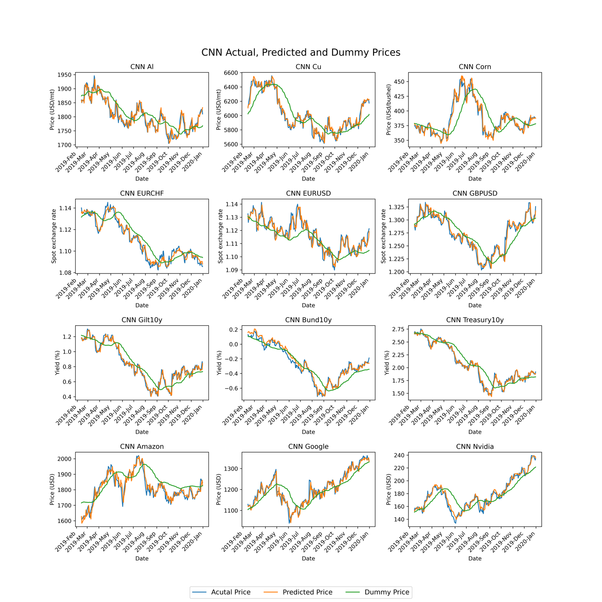

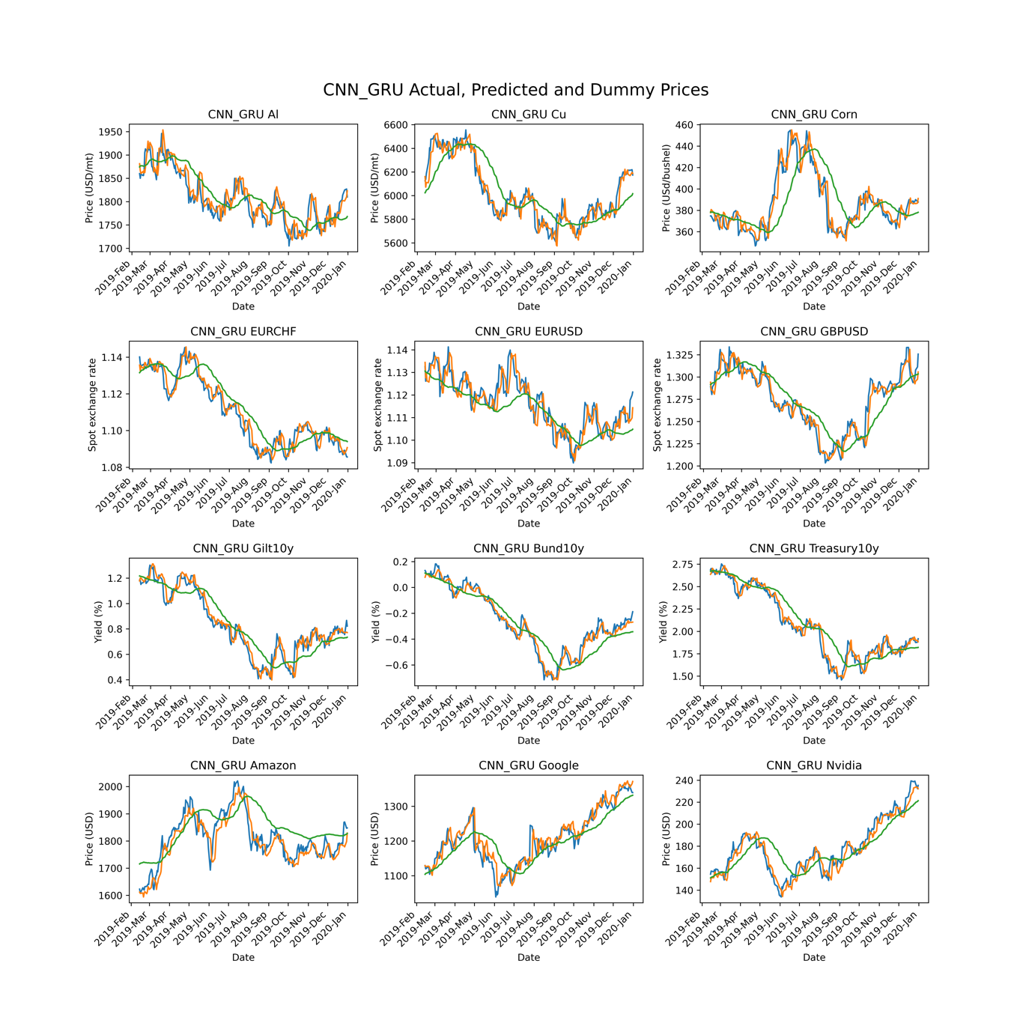

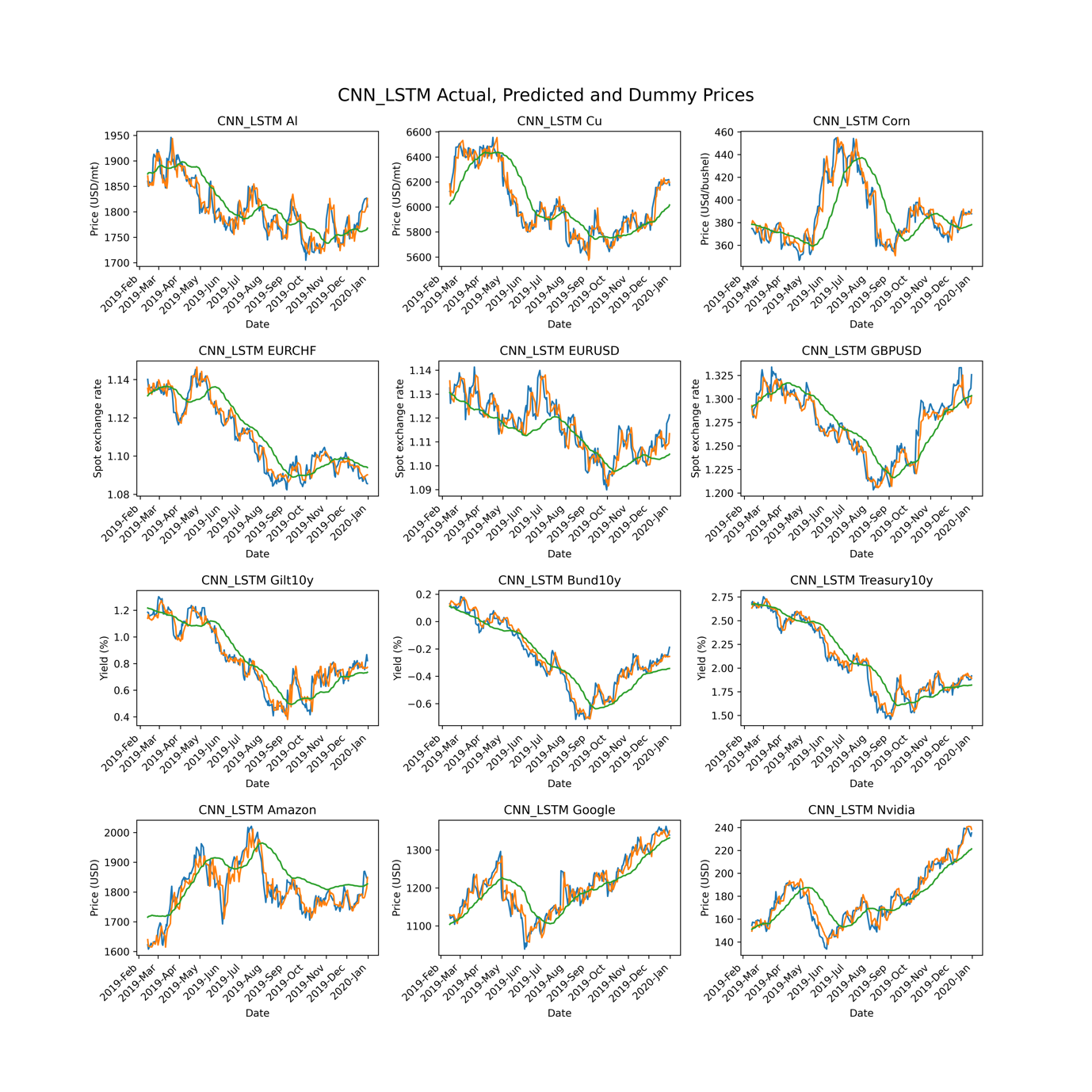

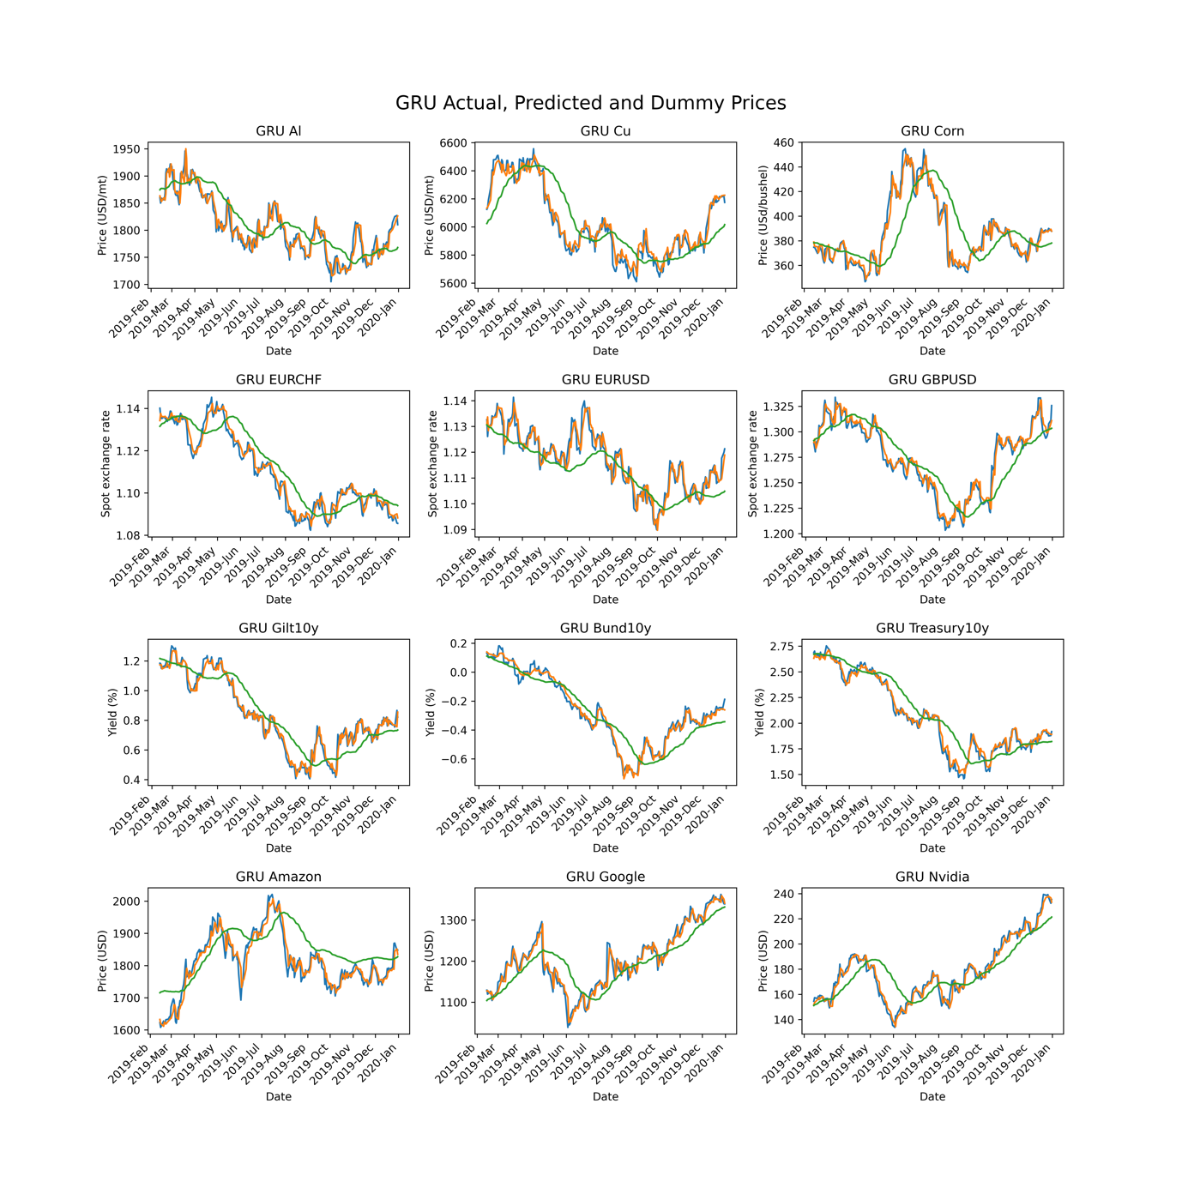

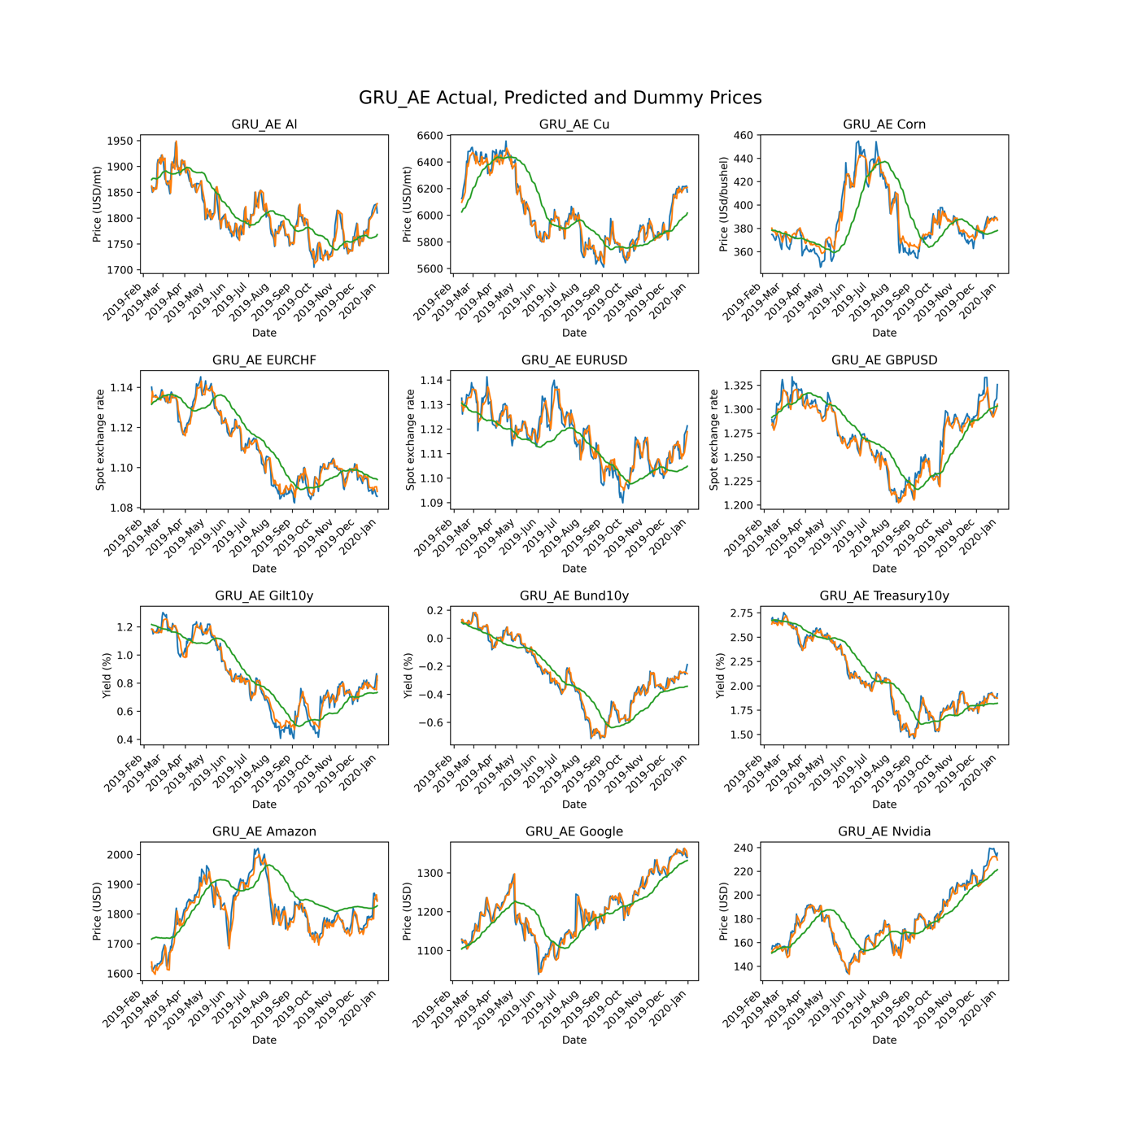

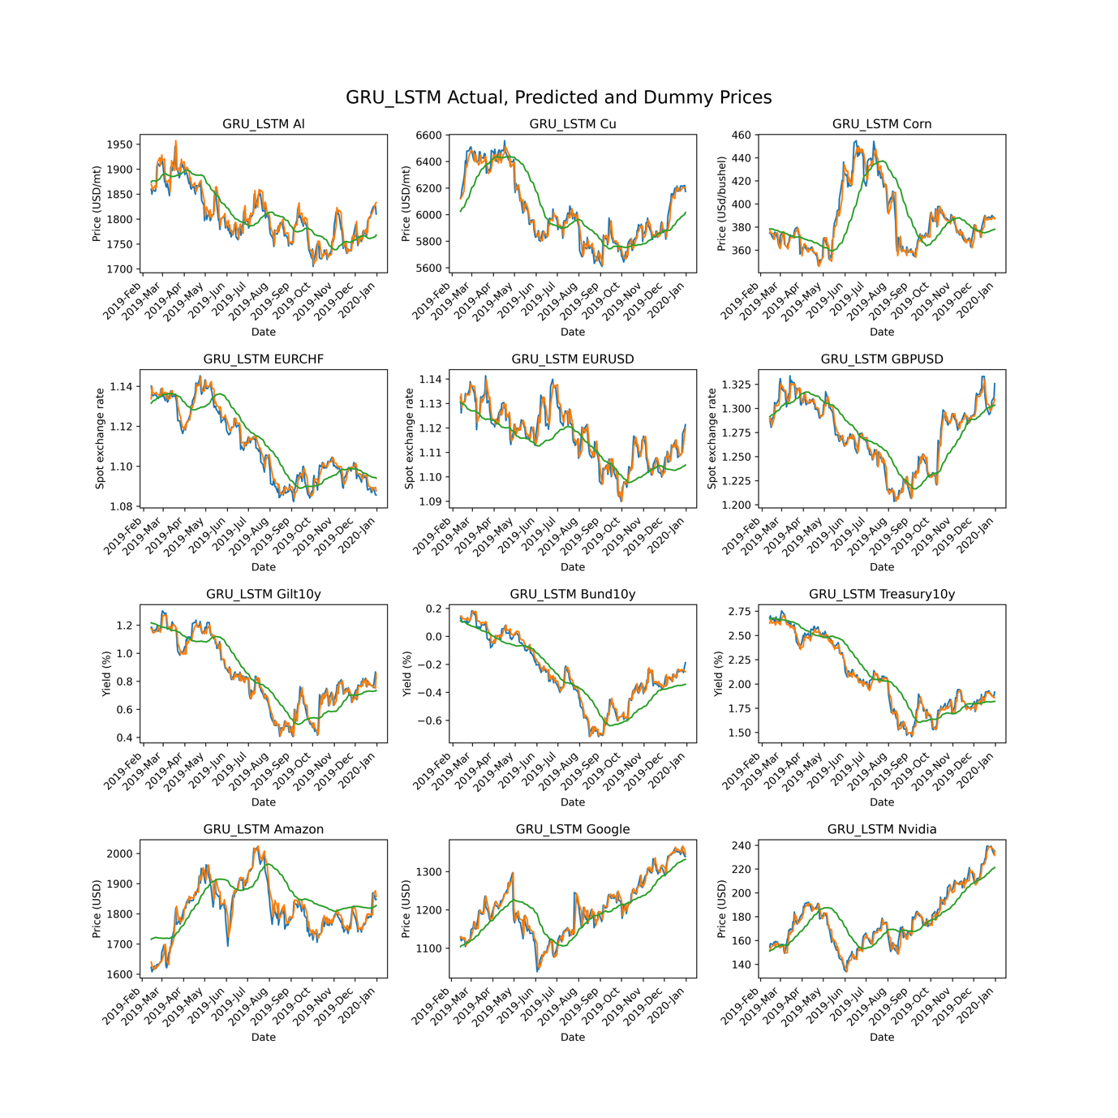

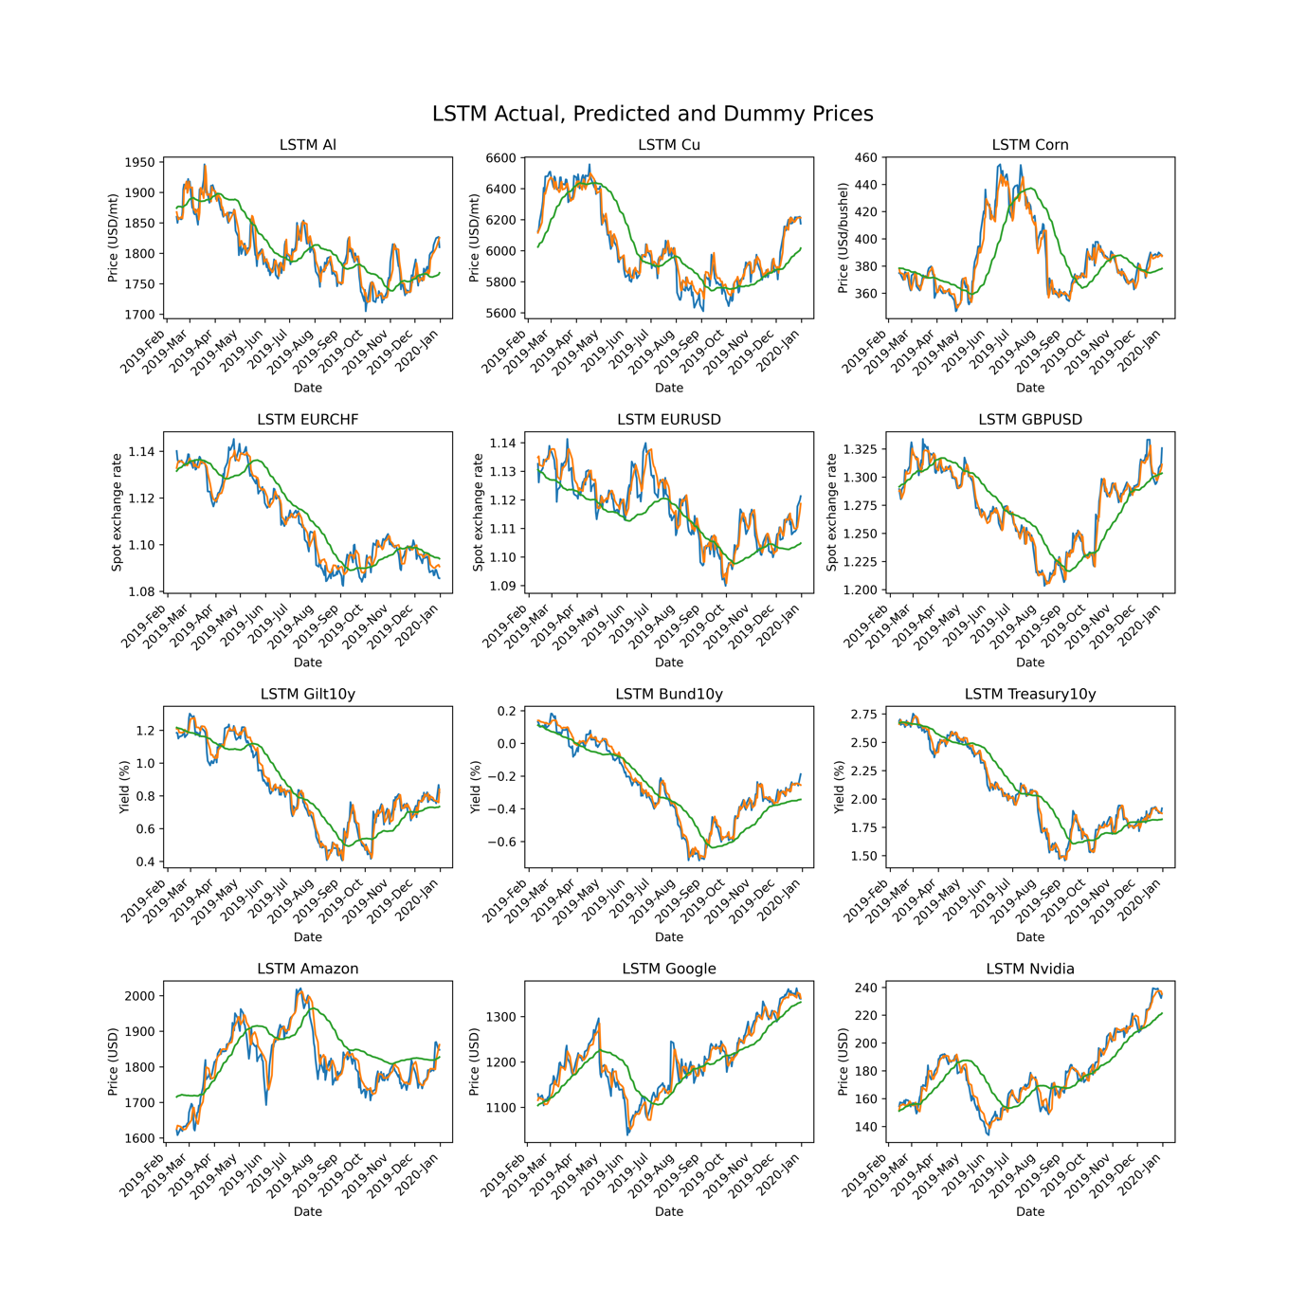

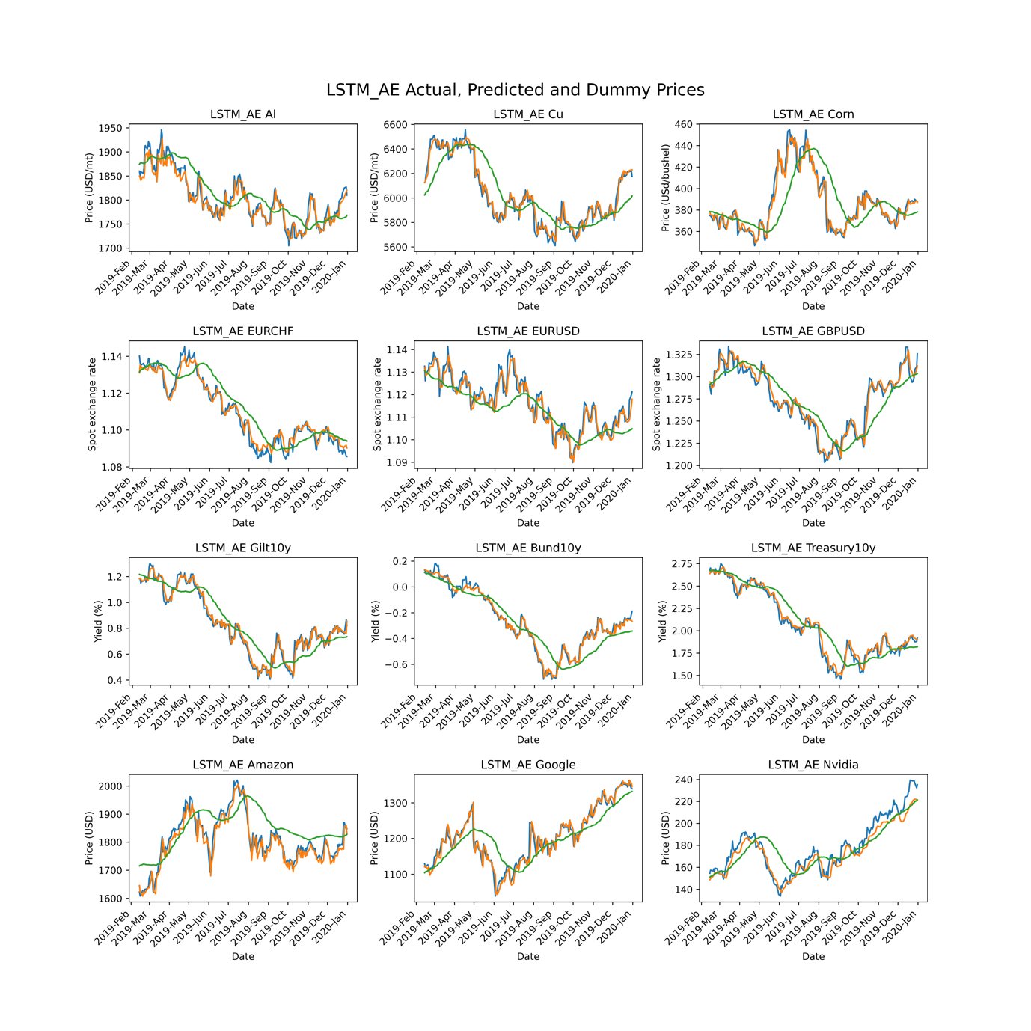

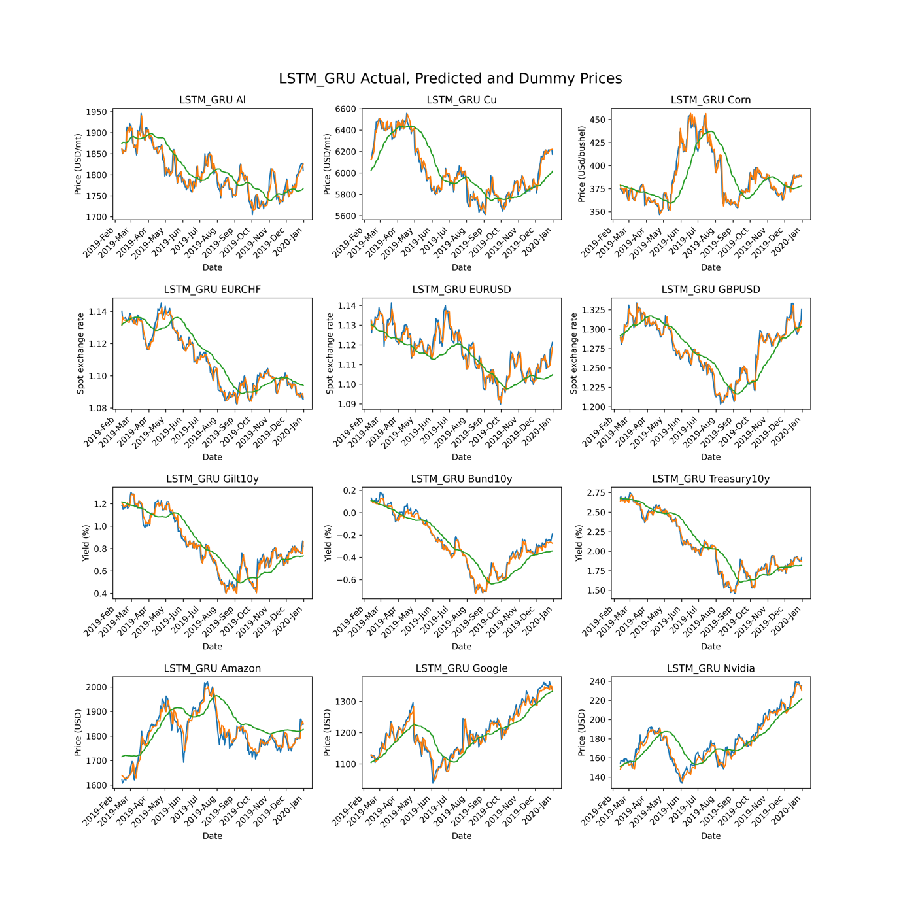

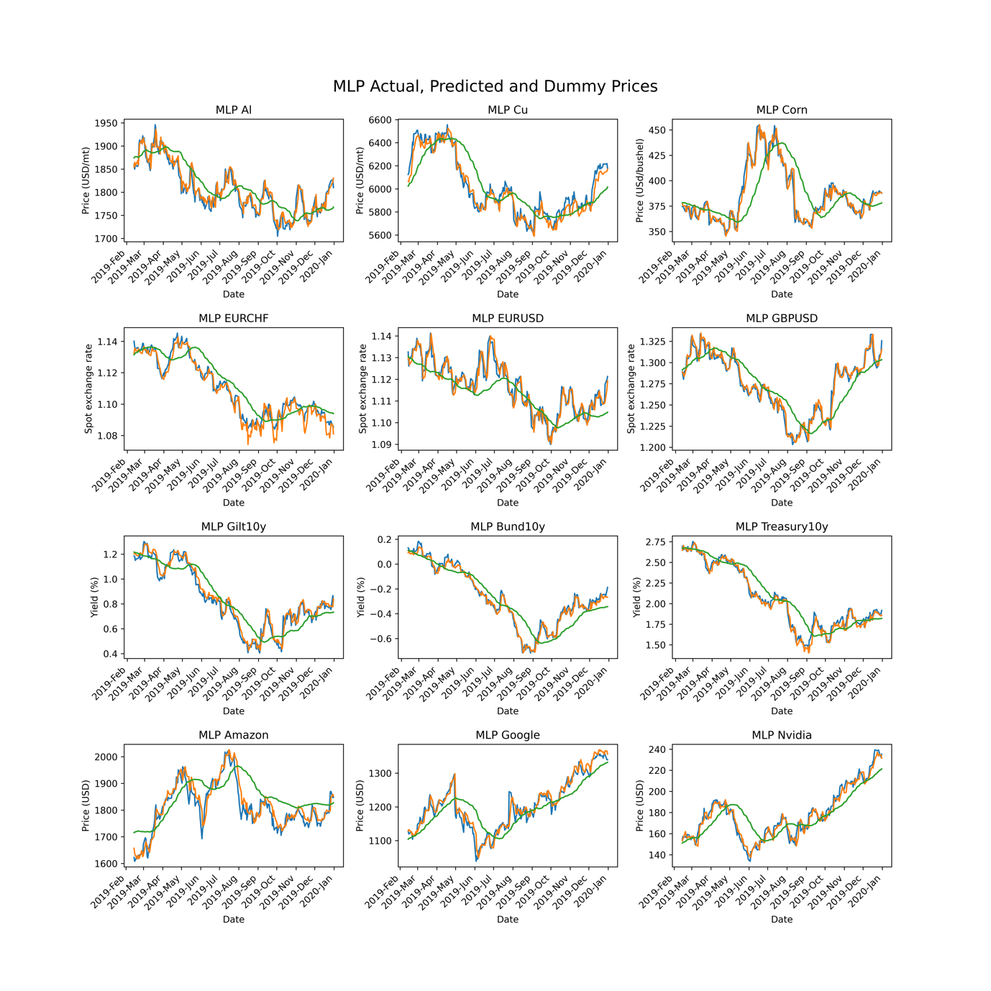

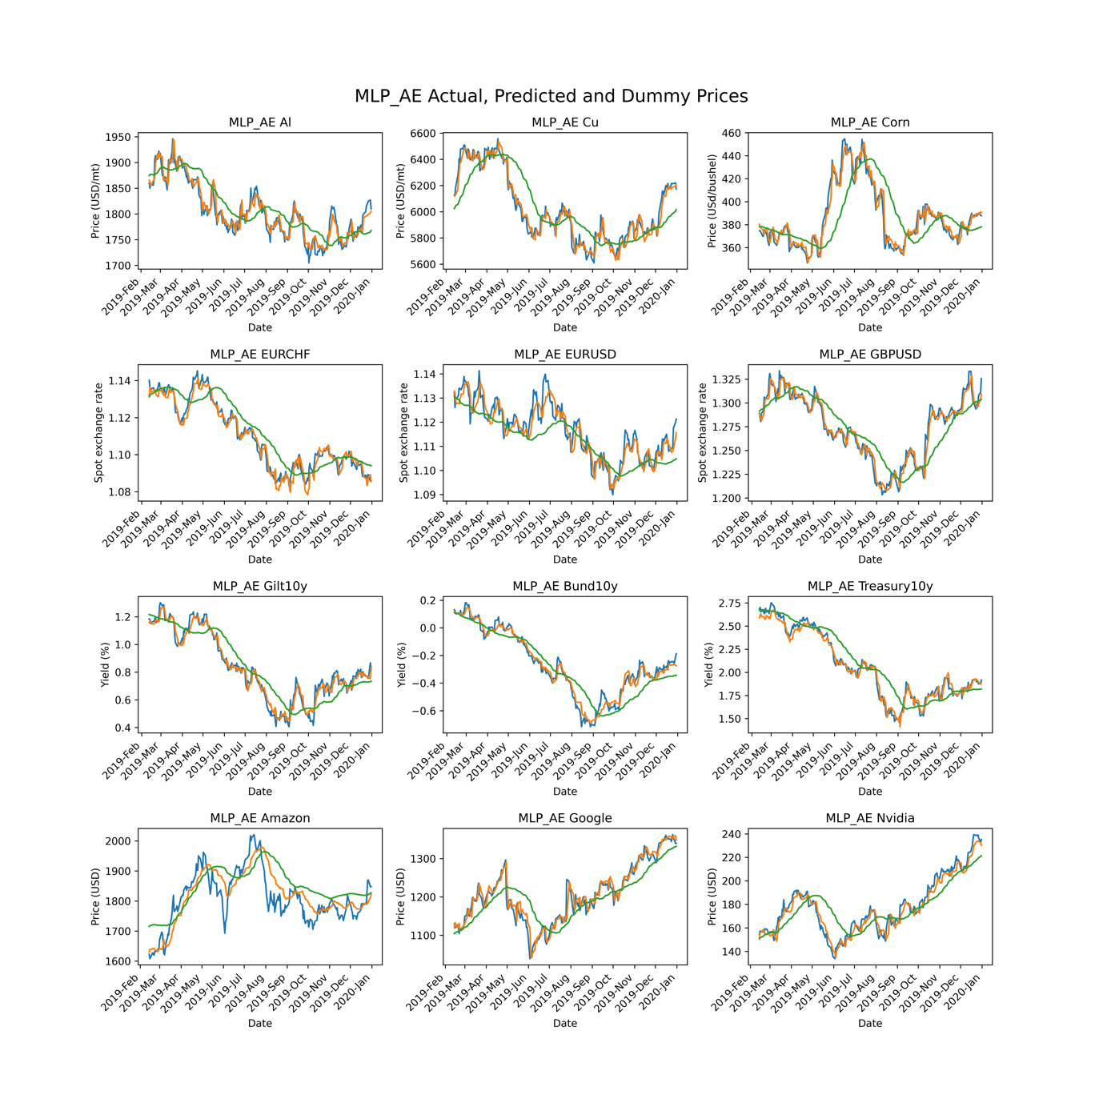

Appendix 5: Plots of model predictions grouped by security

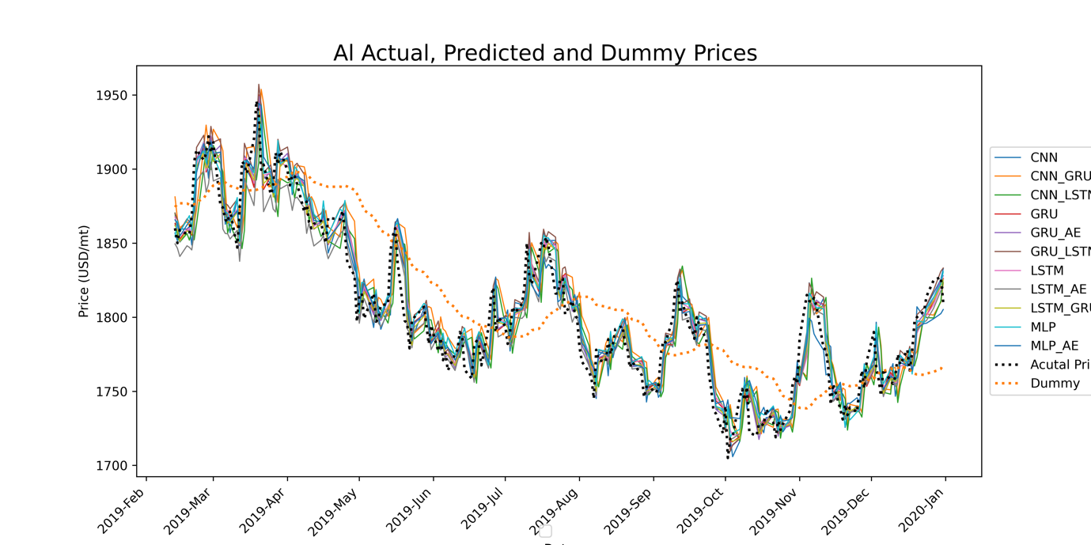

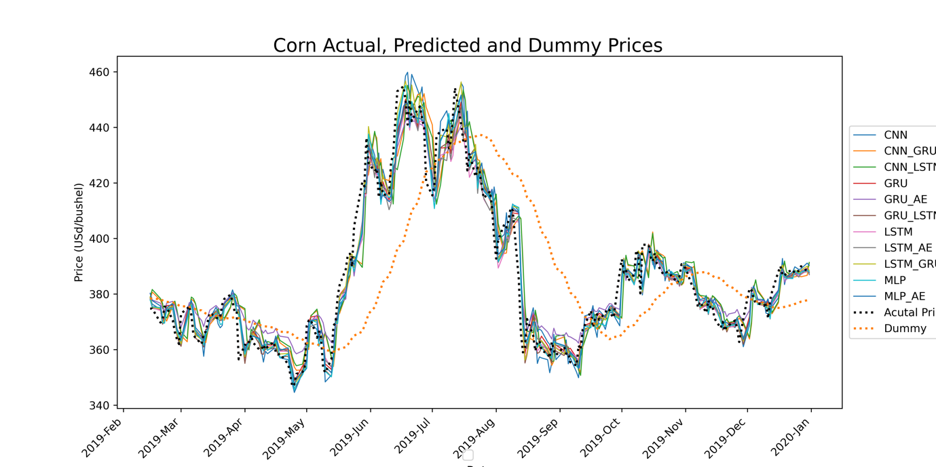

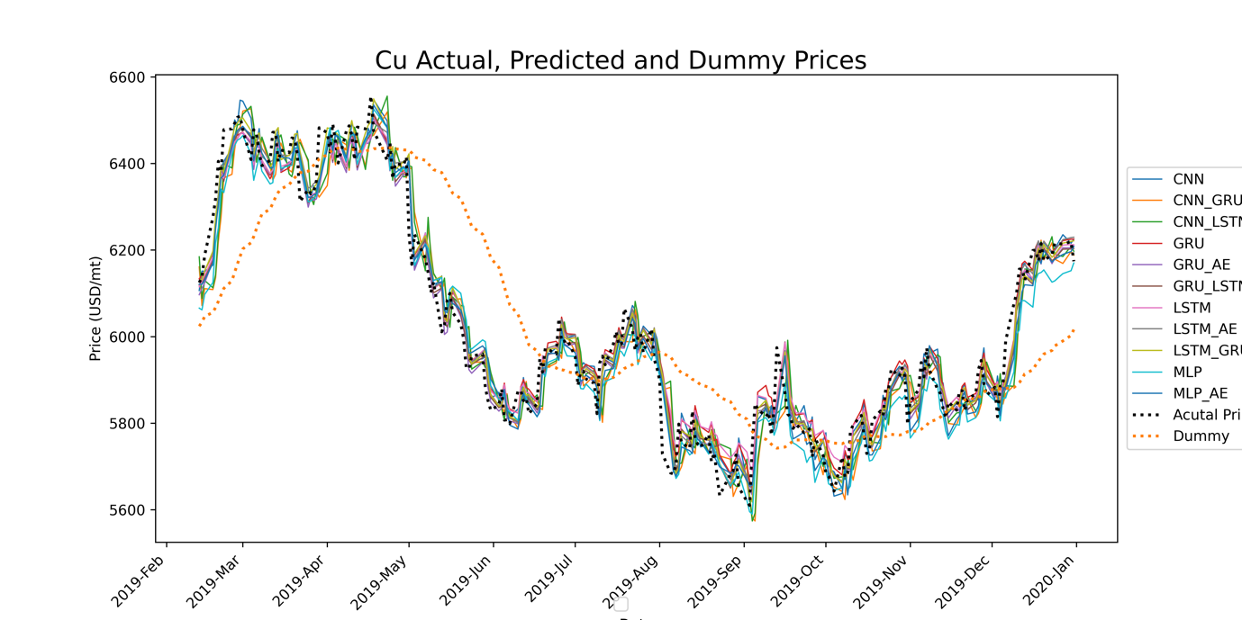

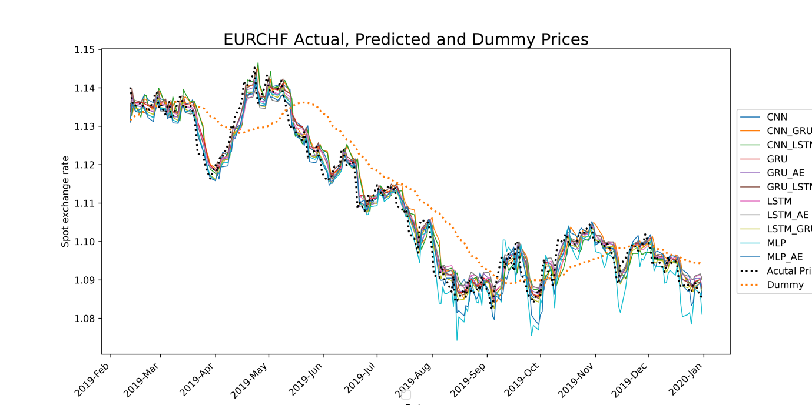

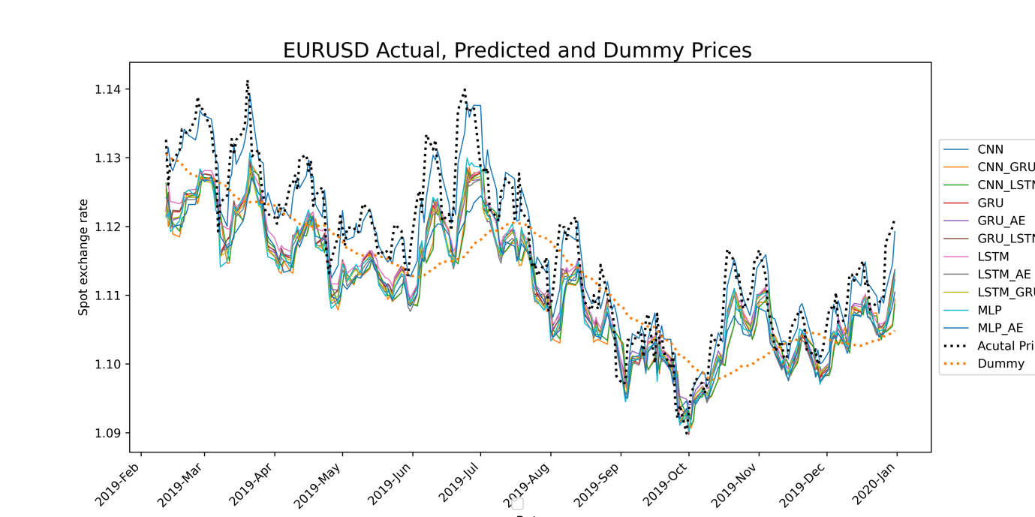

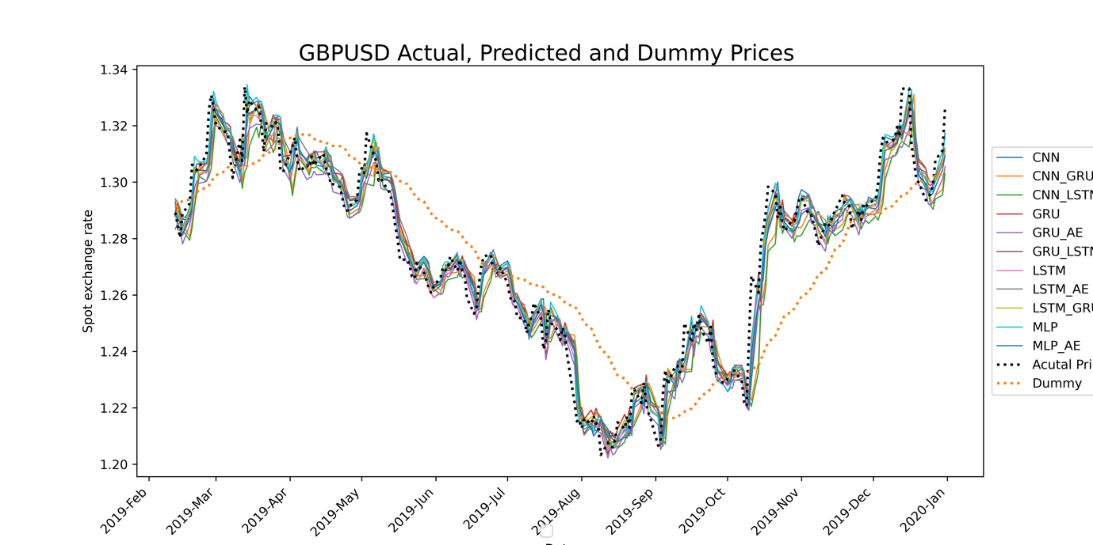

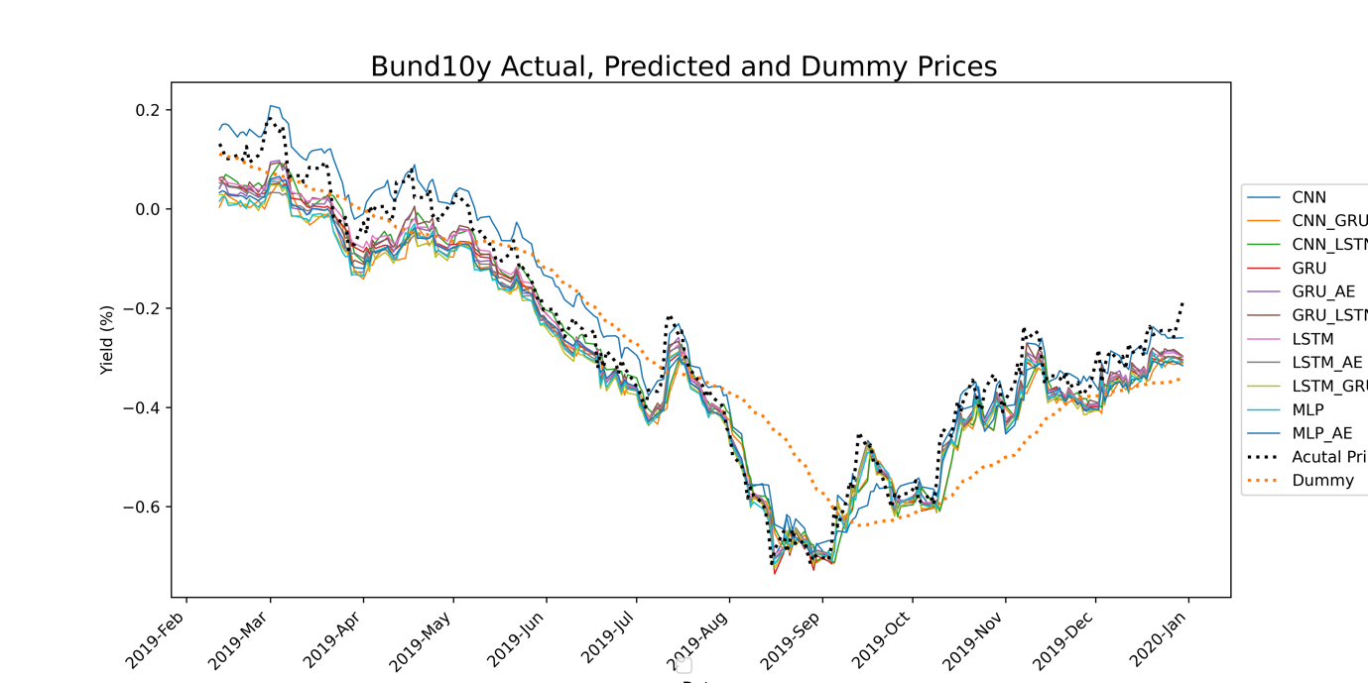

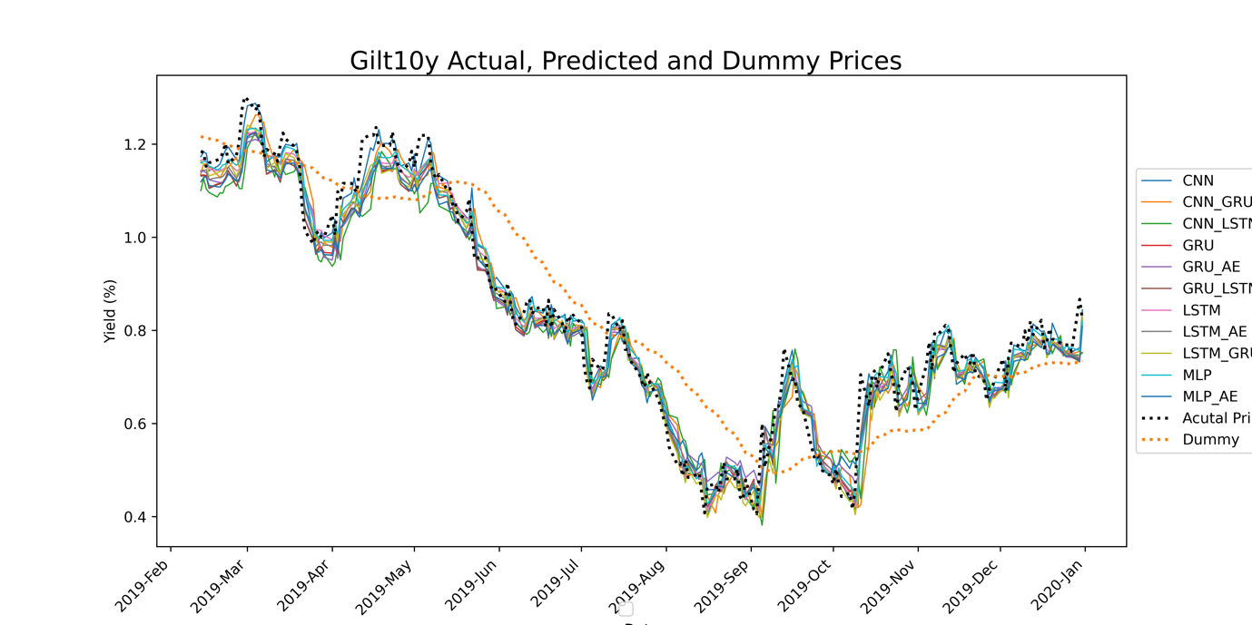

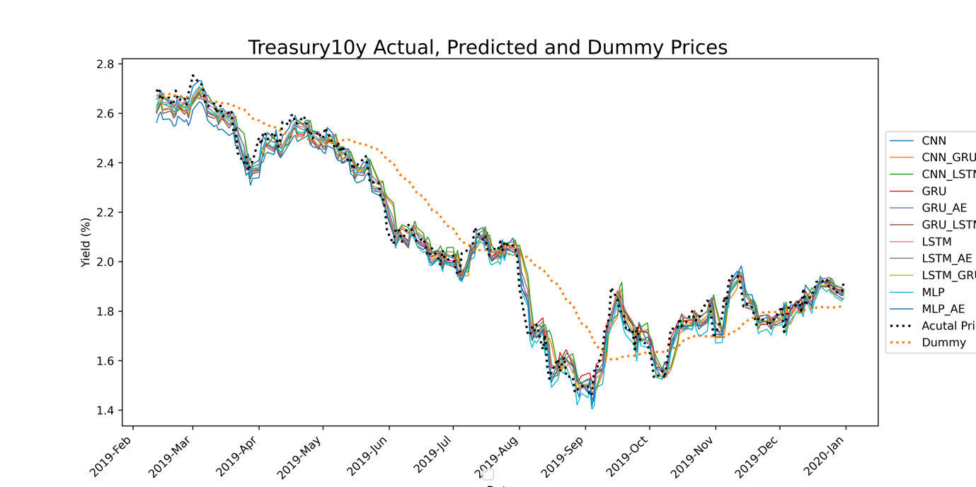

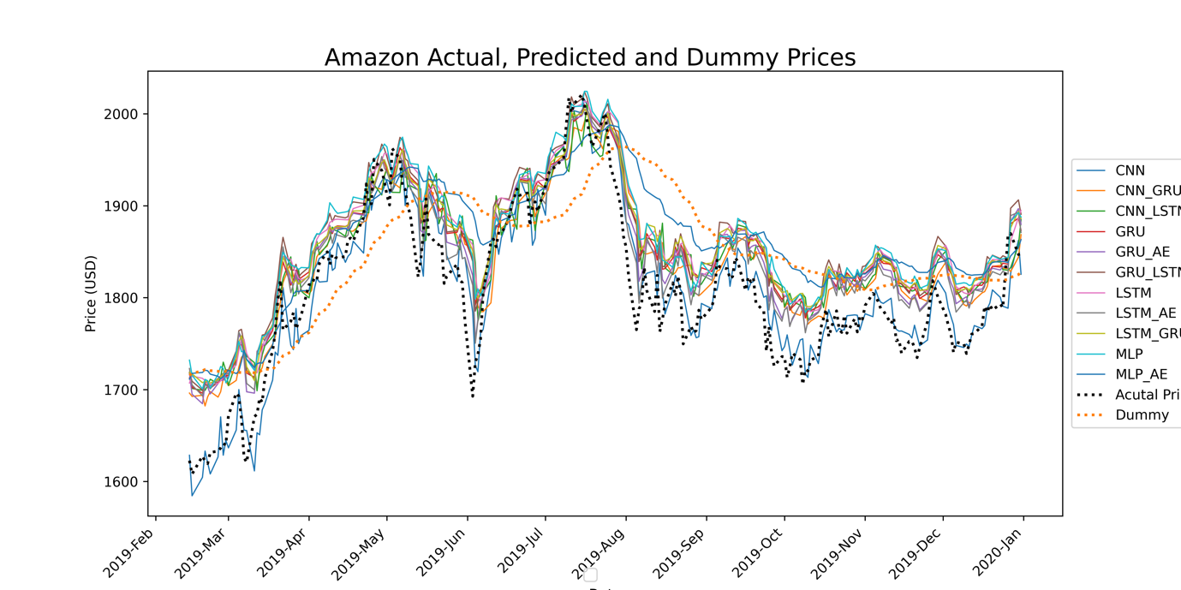

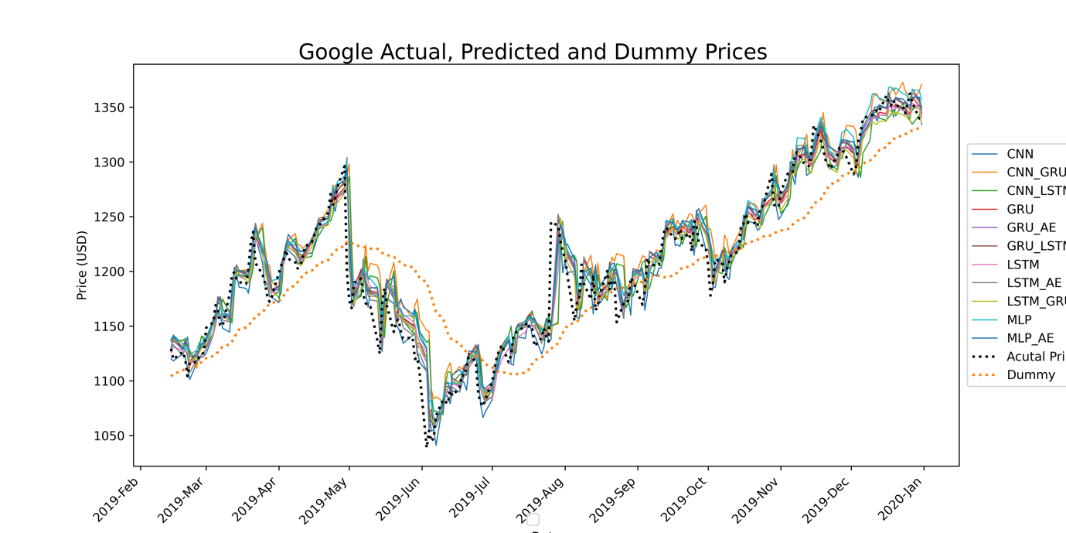



Appendix 6: Plots of extended model predictions

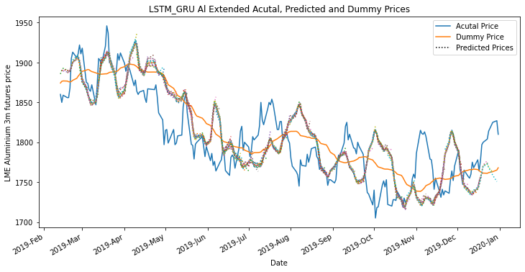

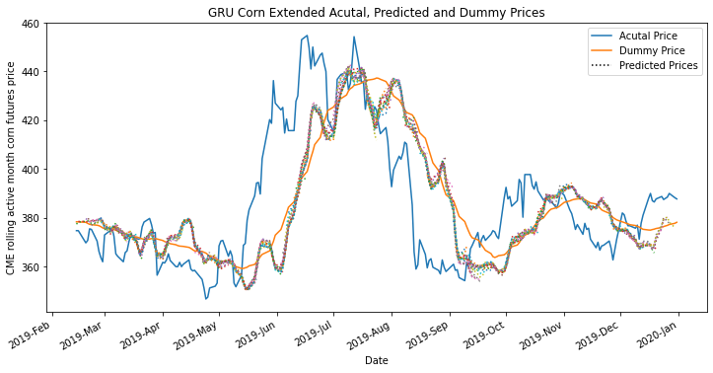

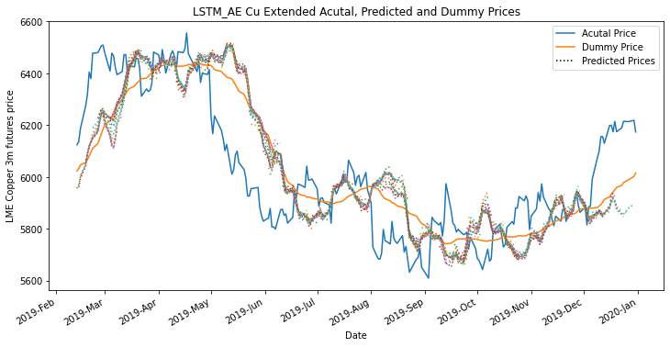

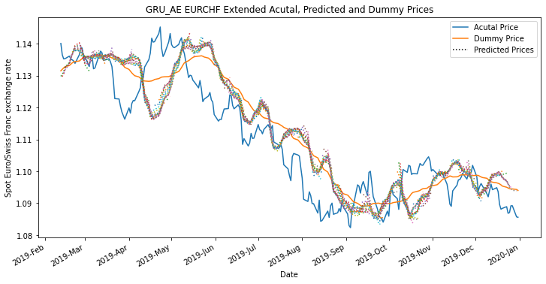

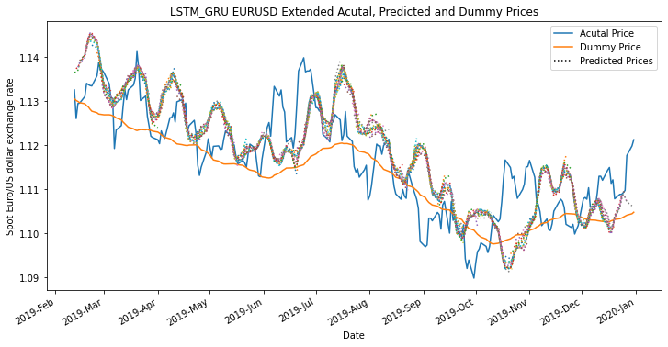

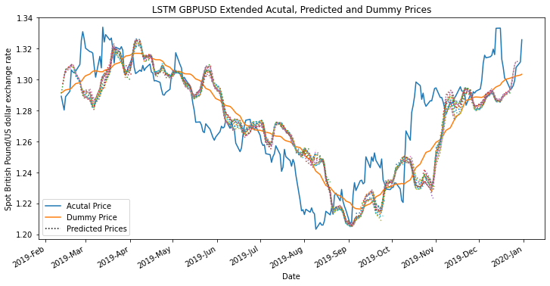

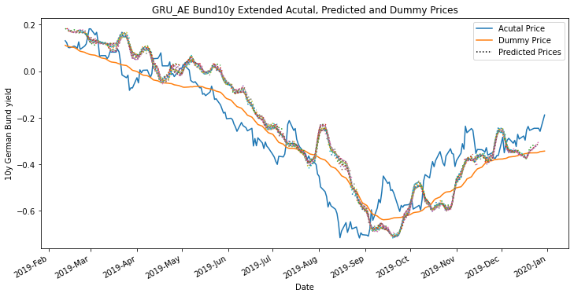

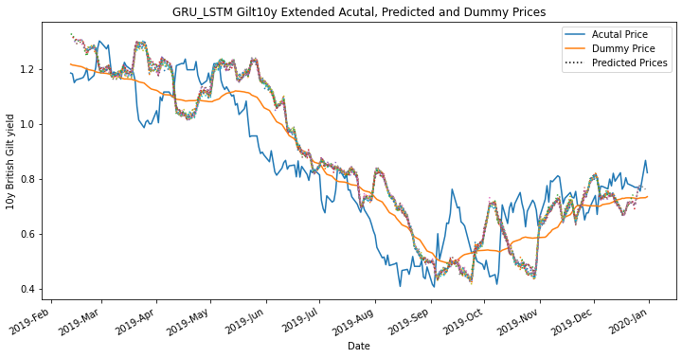

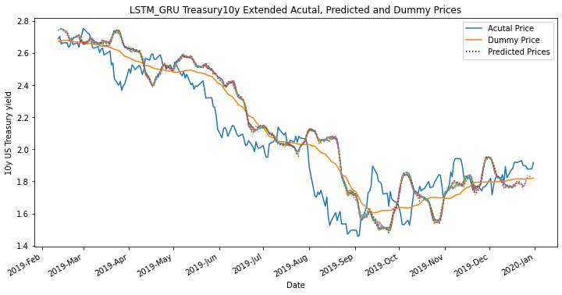

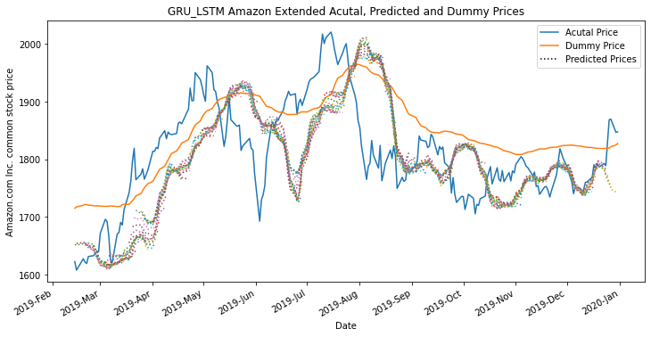

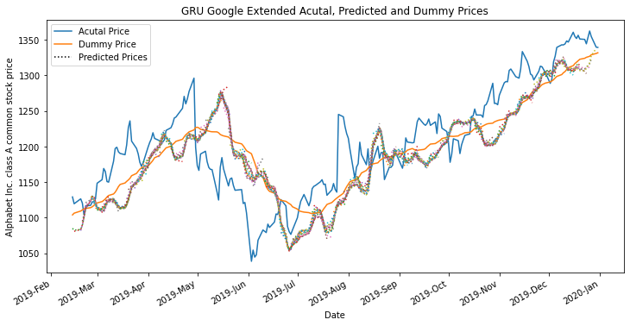

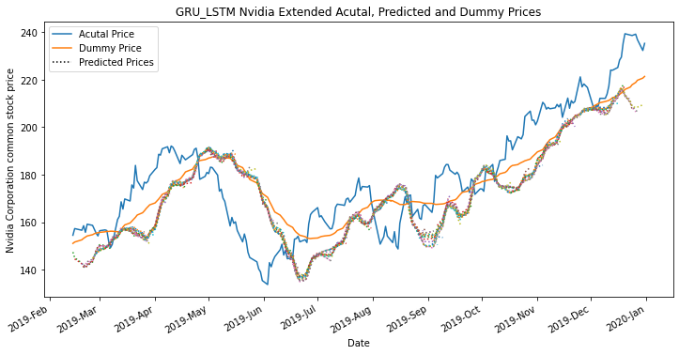

Appendix 7: Security Rankings

|  |  |  |  |  |  |
| --- | --- | --- | --- | --- | --- |
| **Security** | **Model** | **MSE** | **MAE** | **RMSE** | **Score** |
| Al | LSTM_GRU | 0.003619 | 0.0474 | 0.060157 | 1 |
| Al | GRU_AE | 0.003719 | 0.048412 | 0.060985 | 2 |
| Al | GRU | 0.003817 | 0.049056 | 0.061785 | 3 |
| Al | MLP | 0.003844 | 0.049956 | 0.062003 | 4 |
| Al | MLP_AE | 0.003956 | 0.050355 | 0.062897 | 5 |
| Al | LSTM | 0.004005 | 0.049639 | 0.063286 | 6 |
| Al | GRU_LSTM | 0.004271 | 0.052284 | 0.065356 | 7 |
| Al | CNN | 0.004282 | 0.051775 | 0.065435 | 8 |
| Al | LSTM_AE | 0.004457 | 0.052758 | 0.066762 | 9 |
| Al | CNN_LSTM | 0.007341 | 0.066814 | 0.085679 | 10 |
| Al | CNN_GRU | 0.007704 | 0.070362 | 0.08777 | 11 |
| Al | Dummy | 0.019335 | 0.116165 | 0.13905 | 12 |
|  |  |  |  |  |  |
| **Security** | **Model** | **MSE** | **MAE** | **RMSE** | **Score** |
| Amazon | GRU_LSTM | 0.002239 | 0.034979 | 0.047322 | 1 |
| Amazon | GRU | 0.002329 | 0.035903 | 0.04826 | 2 |
| Amazon | GRU_AE | 0.002344 | 0.037674 | 0.04841 | 3 |
| Amazon | LSTM_GRU | 0.002523 | 0.037115 | 0.050234 | 4 |
| Amazon | LSTM_AE | 0.002684 | 0.041261 | 0.051804 | 5 |
| Amazon | CNN | 0.002829 | 0.041323 | 0.053184 | 6 |
| Amazon | MLP | 0.003265 | 0.043473 | 0.057139 | 7 |
| Amazon | LSTM | 0.003324 | 0.042733 | 0.057657 | 8 |
| Amazon | CNN_LSTM | 0.004882 | 0.05342 | 0.069871 | 9 |
| Amazon | CNN_GRU | 0.005364 | 0.05772 | 0.073239 | 10 |
| Amazon | MLP_AE | 0.00884 | 0.073717 | 0.094019 | 11 |
| Amazon | Dummy | 0.034129 | 0.154633 | 0.18474 | 12 |
|  |  |  |  |  |  |
| **Security** | **Model** | **MSE** | **MAE** | **RMSE** | **Score** |
| Bund10y | GRU_AE | 0.000926 | 0.023728 | 0.030425 | 1 |
| Bund10y | MLP | 0.001024 | 0.024575 | 0.032007 | 2 |
| Bund10y | LSTM_AE | 0.001069 | 0.025644 | 0.032694 | 3 |
| Bund10y | LSTM_GRU | 0.001071 | 0.025267 | 0.03272 | 4 |
| Bund10y | GRU_LSTM | 0.001109 | 0.027032 | 0.0333 | 5 |
| Bund10y | GRU | 0.001162 | 0.027262 | 0.034085 | 6 |
| Bund10y | LSTM | 0.001273 | 0.028714 | 0.035682 | 7 |
| Bund10y | MLP_AE | 0.001553 | 0.030137 | 0.039414 | 8 |
| Bund10y | CNN_GRU | 0.001824 | 0.033069 | 0.042712 | 9 |
| Bund10y | CNN | 0.001973 | 0.0367 | 0.044422 | 10 |
| Bund10y | CNN_LSTM | 0.002084 | 0.036352 | 0.045656 | 11 |
| Bund10y | Dummy | 0.011925 | 0.088719 | 0.109202 | 12 |
|  |  |  |  |  |  |
| **Security** | **Model** | **MSE** | **MAE** | **RMSE** | **Score** |
| Corn | GRU | 0.003249 | 0.04053 | 0.056996 | 1 |
| Corn | LSTM_GRU | 0.003417 | 0.04121 | 0.058451 | 2 |
| Corn | MLP | 0.003452 | 0.041842 | 0.058751 | 3 |
| Corn | GRU_LSTM | 0.003472 | 0.041208 | 0.058925 | 4 |
| Corn | LSTM | 0.00356 | 0.042177 | 0.059668 | 5 |
| Corn | MLP_AE | 0.003571 | 0.043118 | 0.059757 | 6 |
| Corn | LSTM_AE | 0.003585 | 0.042656 | 0.059879 | 7 |
| Corn | GRU_AE | 0.004501 | 0.051096 | 0.067092 | 8 |
| Corn | CNN | 0.004581 | 0.048404 | 0.067683 | 9 |
| Corn | CNN_GRU | 0.007381 | 0.063775 | 0.085911 | 10 |
| Corn | CNN_LSTM | 0.007593 | 0.064278 | 0.087137 | 11 |
| Corn | Dummy | 0.041447 | 0.151605 | 0.203585 | 12 |
|  |  |  |  |  |  |
| **Security** | **Model** | **MSE** | **MAE** | **RMSE** | **Score** |
| Cu | LSTM_AE | 0.003 | 0.042771 | 0.054775 | 1 |
| Cu | GRU_AE | 0.003008 | 0.043516 | 0.054844 | 2 |
| Cu | GRU_LSTM | 0.003014 | 0.043444 | 0.054896 | 3 |
| Cu | LSTM_GRU | 0.003088 | 0.043208 | 0.055566 | 4 |
| Cu | MLP_AE | 0.003325 | 0.045312 | 0.057662 | 5 |
| Cu | GRU | 0.003451 | 0.047591 | 0.058741 | 6 |
| Cu | LSTM | 0.003458 | 0.047292 | 0.058807 | 7 |
| Cu | CNN | 0.0036 | 0.047846 | 0.060004 | 8 |
| Cu | MLP | 0.004758 | 0.054926 | 0.068977 | 9 |
| Cu | CNN_LSTM | 0.005842 | 0.059432 | 0.076432 | 10 |
| Cu | CNN_GRU | 0.006104 | 0.060759 | 0.078131 | 11 |
| Cu | Dummy | 0.028899 | 0.132173 | 0.169997 | 12 |
|  |  |  |  |  |  |
| **Security** | **Model** | **MSE** | **MAE** | **RMSE** | **Score** |
| EURCHF | GRU_AE | 0.00189 | 0.033785 | 0.04348 | 1 |
| EURCHF | LSTM_GRU | 0.00207 | 0.035561 | 0.045495 | 2 |
| EURCHF | GRU_LSTM | 0.002328 | 0.038214 | 0.048252 | 3 |
| EURCHF | GRU | 0.00241 | 0.039341 | 0.049093 | 4 |
| EURCHF | LSTM_AE | 0.002736 | 0.040903 | 0.052309 | 5 |
| EURCHF | CNN | 0.002924 | 0.04302 | 0.054078 | 6 |
| EURCHF | MLP_AE | 0.002997 | 0.042516 | 0.054743 | 7 |
| EURCHF | LSTM | 0.003026 | 0.043352 | 0.055006 | 8 |
| EURCHF | CNN_LSTM | 0.004222 | 0.052007 | 0.064979 | 9 |
| EURCHF | MLP | 0.004309 | 0.05003 | 0.065642 | 10 |
| EURCHF | CNN_GRU | 0.004397 | 0.052347 | 0.066309 | 11 |
| EURCHF | Dummy | 0.016968 | 0.10864 | 0.130262 | 12 |
|  |  |  |  |  |  |
| **Security** | **Model** | **MSE** | **MAE** | **RMSE** | **Score** |
| EURUSD | LSTM_GRU | 0.002662 | 0.039449 | 0.051592 | 1 |
| EURUSD | GRU_LSTM | 0.002684 | 0.039162 | 0.051803 | 2 |
| EURUSD | GRU | 0.00277 | 0.039854 | 0.052631 | 3 |
| EURUSD | GRU_AE | 0.002799 | 0.0406 | 0.052909 | 4 |
| EURUSD | CNN | 0.002823 | 0.041446 | 0.053128 | 5 |
| EURUSD | MLP | 0.002828 | 0.041666 | 0.053181 | 6 |
| EURUSD | LSTM_AE | 0.002982 | 0.042022 | 0.05461 | 7 |
| EURUSD | LSTM | 0.003673 | 0.04679 | 0.060608 | 8 |
| EURUSD | MLP_AE | 0.004121 | 0.050867 | 0.064191 | 9 |
| EURUSD | CNN_GRU | 0.005758 | 0.05989 | 0.075883 | 10 |
| EURUSD | CNN_LSTM | 0.005811 | 0.060148 | 0.07623 | 11 |
| EURUSD | Dummy | 0.023689 | 0.119703 | 0.153911 | 12 |
|  |  |  |  |  |  |
| **Security** | **Model** | **MSE** | **MAE** | **RMSE** | **Score** |
| GBPUSD | LSTM | 0.002516 | 0.036615 | 0.05016 | 1 |
| GBPUSD | LSTM_GRU | 0.002553 | 0.037499 | 0.050528 | 2 |
| GBPUSD | GRU_LSTM | 0.002556 | 0.037807 | 0.050553 | 3 |
| GBPUSD | MLP | 0.002642 | 0.038993 | 0.051399 | 4 |
| GBPUSD | GRU | 0.002909 | 0.041625 | 0.053939 | 5 |
| GBPUSD | MLP_AE | 0.003023 | 0.041234 | 0.054978 | 6 |
| GBPUSD | CNN | 0.003404 | 0.042789 | 0.058341 | 7 |
| GBPUSD | LSTM_AE | 0.00342 | 0.044443 | 0.05848 | 8 |
| GBPUSD | GRU_AE | 0.00353 | 0.043521 | 0.059413 | 9 |
| GBPUSD | CNN_GRU | 0.005522 | 0.055139 | 0.074308 | 10 |
| GBPUSD | CNN_LSTM | 0.006242 | 0.058181 | 0.079007 | 11 |
| GBPUSD | Dummy | 0.021934 | 0.119493 | 0.148101 | 12 |
|  |  |  |  |  |  |
| **Security** | **Model** | **MSE** | **MAE** | **RMSE** | **Score** |
| Gilt10y | GRU_LSTM | 0.00174 | 0.032736 | 0.041712 | 1 |
| Gilt10y | GRU | 0.001749 | 0.033293 | 0.041823 | 2 |
| Gilt10y | LSTM_AE | 0.001806 | 0.033712 | 0.042501 | 3 |
| Gilt10y | CNN | 0.001809 | 0.033311 | 0.042531 | 4 |
| Gilt10y | LSTM_GRU | 0.001941 | 0.03439 | 0.044058 | 5 |
| Gilt10y | MLP_AE | 0.002039 | 0.035479 | 0.045157 | 6 |
| Gilt10y | GRU_AE | 0.002122 | 0.036199 | 0.046068 | 7 |
| Gilt10y | LSTM | 0.002128 | 0.036908 | 0.046134 | 8 |
| Gilt10y | MLP | 0.002279 | 0.038613 | 0.047734 | 9 |
| Gilt10y | CNN_GRU | 0.003639 | 0.04503 | 0.060323 | 10 |
| Gilt10y | CNN_LSTM | 0.004042 | 0.047708 | 0.063574 | 11 |
| Gilt10y | Dummy | 0.013892 | 0.09978 | 0.117863 | 12 |
|  |  |  |  |  |  |
| **Security** | **Model** | **MSE** | **MAE** | **RMSE** | **Score** |
| Google | GRU | 0.002602 | 0.034234 | 0.051013 | 1 |
| Google | GRU_LSTM | 0.002627 | 0.034244 | 0.05125 | 2 |
| Google | GRU_AE | 0.002627 | 0.034243 | 0.051254 | 3 |
| Google | LSTM_AE | 0.002874 | 0.037039 | 0.053609 | 4 |
| Google | LSTM_GRU | 0.003053 | 0.039521 | 0.055251 | 5 |
| Google | CNN | 0.003091 | 0.038765 | 0.0556 | 6 |
| Google | MLP_AE | 0.003189 | 0.03906 | 0.056475 | 7 |
| Google | MLP | 0.003212 | 0.039945 | 0.056679 | 8 |
| Google | LSTM | 0.003404 | 0.041219 | 0.058341 | 9 |
| Google | CNN_LSTM | 0.005741 | 0.055641 | 0.075771 | 10 |
| Google | CNN_GRU | 0.006321 | 0.056461 | 0.079504 | 11 |
| Google | Dummy | 0.017869 | 0.107493 | 0.133676 | 12 |
|  |  |  |  |  |  |
| **Security** | **Model** | **MSE** | **MAE** | **RMSE** | **Score** |
| Nvidia | GRU_LSTM | 0.001341 | 0.027575 | 0.036617 | 1 |
| Nvidia | GRU | 0.001371 | 0.028062 | 0.037027 | 2 |
| Nvidia | GRU_AE | 0.001522 | 0.029688 | 0.03901 | 3 |
| Nvidia | LSTM | 0.001718 | 0.031567 | 0.041453 | 4 |
| Nvidia | CNN | 0.00175 | 0.031841 | 0.041832 | 5 |
| Nvidia | MLP | 0.001751 | 0.032292 | 0.041849 | 6 |
| Nvidia | LSTM_GRU | 0.002004 | 0.035316 | 0.044768 | 7 |
| Nvidia | MLP_AE | 0.002345 | 0.038853 | 0.048421 | 8 |
| Nvidia | CNN_LSTM | 0.002951 | 0.042897 | 0.054322 | 9 |
| Nvidia | CNN_GRU | 0.003424 | 0.046397 | 0.058518 | 10 |
| Nvidia | LSTM_AE | 0.005039 | 0.057601 | 0.070989 | 11 |
| Nvidia | Dummy | 0.016238 | 0.103206 | 0.127429 | 12 |
|  |  |  |  |  |  |
| **Security** | **Model** | **MSE** | **MAE** | **RMSE** | **Score** |
| Treasury10y | LSTM_GRU | 0.001056 | 0.024796 | 0.032497 | 1 |
| Treasury10y | GRU_AE | 0.001066 | 0.02515 | 0.032642 | 2 |
| Treasury10y | CNN | 0.001113 | 0.025451 | 0.033363 | 3 |
| Treasury10y | GRU_LSTM | 0.00115 | 0.026558 | 0.033905 | 4 |
| Treasury10y | LSTM | 0.001199 | 0.026206 | 0.034631 | 5 |
| Treasury10y | GRU | 0.001261 | 0.027422 | 0.035505 | 6 |
| Treasury10y | MLP | 0.001414 | 0.029093 | 0.037607 | 7 |
| Treasury10y | MLP_AE | 0.001517 | 0.031135 | 0.038943 | 8 |
| Treasury10y | LSTM_AE | 0.001563 | 0.030144 | 0.03953 | 9 |
| Treasury10y | CNN_GRU | 0.002303 | 0.036542 | 0.047994 | 10 |
| Treasury10y | CNN_LSTM | 0.002611 | 0.038968 | 0.051095 | 11 |
| Treasury10y | Dummy | 0.011908 | 0.082874 | 0.109124 | 12 |

Appendix 7: Model Rankings

|  |  |  |  |  |  |
| --- | --- | --- | --- | --- | --- |
| **Model** | **Security** | **MSE** | **MAE** | **RMSE** | **Score** |
| CNN | Treasury10y | 0.001113 | 0.025451 | 0.033363 | 1 |
| CNN | Nvidia | 0.00175 | 0.031841 | 0.041832 | 2 |
| CNN | Gilt10y | 0.001809 | 0.033311 | 0.042531 | 3 |
| CNN | Bund10y | 0.001973 | 0.0367 | 0.044422 | 4 |
| CNN | EURUSD | 0.002823 | 0.041446 | 0.053128 | 5 |
| CNN | Amazon | 0.002829 | 0.041323 | 0.053184 | 6 |
| CNN | EURCHF | 0.002924 | 0.04302 | 0.054078 | 7 |
| CNN | Google | 0.003091 | 0.038765 | 0.0556 | 8 |
| CNN | GBPUSD | 0.003404 | 0.042789 | 0.058341 | 9 |
| CNN | Cu | 0.0036 | 0.047846 | 0.060004 | 10 |
| CNN | Al | 0.004282 | 0.051775 | 0.065435 | 11 |
| CNN | Corn | 0.004581 | 0.048404 | 0.067683 | 12 |
|  |  |  |  |  |  |
| **Model** | **Security** | **MSE** | **MAE** | **RMSE** | **Score** |
| CNN_GRU | Bund10y | 0.001824 | 0.033069 | 0.042712 | 1 |
| CNN_GRU | Treasury10y | 0.002303 | 0.036542 | 0.047994 | 2 |
| CNN_GRU | Nvidia | 0.003424 | 0.046397 | 0.058518 | 3 |
| CNN_GRU | Gilt10y | 0.003639 | 0.04503 | 0.060323 | 4 |
| CNN_GRU | EURCHF | 0.004397 | 0.052347 | 0.066309 | 5 |
| CNN_GRU | Amazon | 0.005364 | 0.05772 | 0.073239 | 6 |
| CNN_GRU | GBPUSD | 0.005522 | 0.055139 | 0.074308 | 7 |
| CNN_GRU | EURUSD | 0.005758 | 0.05989 | 0.075883 | 8 |
| CNN_GRU | Cu | 0.006104 | 0.060759 | 0.078131 | 9 |
| CNN_GRU | Google | 0.006321 | 0.056461 | 0.079504 | 10 |
| CNN_GRU | Corn | 0.007381 | 0.063775 | 0.085911 | 11 |
| CNN_GRU | Al | 0.007704 | 0.070362 | 0.08777 | 12 |
|  |  |  |  |  |  |
| **Model** | **Security** | **MSE** | **MAE** | **RMSE** | **Score** |
| CNN_LSTM | Bund10y | 0.002084 | 0.036352 | 0.045656 | 1 |
| CNN_LSTM | Treasury10y | 0.002611 | 0.038968 | 0.051095 | 2 |
| CNN_LSTM | Nvidia | 0.002951 | 0.042897 | 0.054322 | 3 |
| CNN_LSTM | Gilt10y | 0.004042 | 0.047708 | 0.063574 | 4 |
| CNN_LSTM | EURCHF | 0.004222 | 0.052007 | 0.064979 | 5 |
| CNN_LSTM | Amazon | 0.004882 | 0.05342 | 0.069871 | 6 |
| CNN_LSTM | Google | 0.005741 | 0.055641 | 0.075771 | 7 |
| CNN_LSTM | EURUSD | 0.005811 | 0.060148 | 0.07623 | 8 |
| CNN_LSTM | Cu | 0.005842 | 0.059432 | 0.076432 | 9 |
| CNN_LSTM | GBPUSD | 0.006242 | 0.058181 | 0.079007 | 10 |
| CNN_LSTM | Al | 0.007341 | 0.066814 | 0.085679 | 11 |
| CNN_LSTM | Corn | 0.007593 | 0.064278 | 0.087137 | 12 |
|  |  |  |  |  |  |
| **Model** | **Security** | **MSE** | **MAE** | **RMSE** | **Score** |
| Dummy | Treasury10y | 0.011908 | 0.082874 | 0.109124 | 1 |
| Dummy | Bund10y | 0.011925 | 0.088719 | 0.109202 | 2 |
| Dummy | Gilt10y | 0.013892 | 0.09978 | 0.117863 | 3 |
| Dummy | Nvidia | 0.016238 | 0.103206 | 0.127429 | 4 |
| Dummy | EURCHF | 0.016968 | 0.10864 | 0.130262 | 5 |
| Dummy | Google | 0.017869 | 0.107493 | 0.133676 | 6 |
| Dummy | Al | 0.019335 | 0.116165 | 0.13905 | 7 |
| Dummy | GBPUSD | 0.021934 | 0.119493 | 0.148101 | 8 |
| Dummy | EURUSD | 0.023689 | 0.119703 | 0.153911 | 9 |
| Dummy | Cu | 0.028899 | 0.132173 | 0.169997 | 10 |
| Dummy | Amazon | 0.034129 | 0.154633 | 0.18474 | 11 |
| Dummy | Corn | 0.041447 | 0.151605 | 0.203585 | 12 |
|  |  |  |  |  |  |
| **Model** | **Security** | **MSE** | **MAE** | **RMSE** | **Score** |
| GRU | Bund10y | 0.001162 | 0.027262 | 0.034085 | 1 |
| GRU | Treasury10y | 0.001261 | 0.027422 | 0.035505 | 2 |
| GRU | Nvidia | 0.001371 | 0.028062 | 0.037027 | 3 |
| GRU | Gilt10y | 0.001749 | 0.033293 | 0.041823 | 4 |
| GRU | Amazon | 0.002329 | 0.035903 | 0.04826 | 5 |
| GRU | EURCHF | 0.00241 | 0.039341 | 0.049093 | 6 |
| GRU | Google | 0.002602 | 0.034234 | 0.051013 | 7 |
| GRU | EURUSD | 0.00277 | 0.039854 | 0.052631 | 8 |
| GRU | GBPUSD | 0.002909 | 0.041625 | 0.053939 | 9 |
| GRU | Corn | 0.003249 | 0.04053 | 0.056996 | 10 |
| GRU | Cu | 0.003451 | 0.047591 | 0.058741 | 11 |
| GRU | Al | 0.003817 | 0.049056 | 0.061785 | 12 |
|  |  |  |  |  |  |
| **Model** | **Security** | **MSE** | **MAE** | **RMSE** | **Score** |
| GRU_AE | Bund10y | 0.000926 | 0.023728 | 0.030425 | 1 |
| GRU_AE | Treasury10y | 0.001066 | 0.02515 | 0.032642 | 2 |
| GRU_AE | Nvidia | 0.001522 | 0.029688 | 0.03901 | 3 |
| GRU_AE | EURCHF | 0.00189 | 0.033785 | 0.04348 | 4 |
| GRU_AE | Gilt10y | 0.002122 | 0.036199 | 0.046068 | 5 |
| GRU_AE | Amazon | 0.002344 | 0.037674 | 0.04841 | 6 |
| GRU_AE | Google | 0.002627 | 0.034243 | 0.051254 | 7 |
| GRU_AE | EURUSD | 0.002799 | 0.0406 | 0.052909 | 8 |
| GRU_AE | Cu | 0.003008 | 0.043516 | 0.054844 | 9 |
| GRU_AE | GBPUSD | 0.00353 | 0.043521 | 0.059413 | 10 |
| GRU_AE | Al | 0.003719 | 0.048412 | 0.060985 | 11 |
| GRU_AE | Corn | 0.004501 | 0.051096 | 0.067092 | 12 |
|  |  |  |  |  |  |
| **Model** | **Security** | **MSE** | **MAE** | **RMSE** | **Score** |
| GRU_LSTM | Bund10y | 0.001109 | 0.027032 | 0.0333 | 1 |
| GRU_LSTM | Treasury10y | 0.00115 | 0.026558 | 0.033905 | 2 |
| GRU_LSTM | Nvidia | 0.001341 | 0.027575 | 0.036617 | 3 |
| GRU_LSTM | Gilt10y | 0.00174 | 0.032736 | 0.041712 | 4 |
| GRU_LSTM | Amazon | 0.002239 | 0.034979 | 0.047322 | 5 |
| GRU_LSTM | EURCHF | 0.002328 | 0.038214 | 0.048252 | 6 |
| GRU_LSTM | GBPUSD | 0.002556 | 0.037807 | 0.050553 | 7 |
| GRU_LSTM | Google | 0.002627 | 0.034244 | 0.05125 | 8 |
| GRU_LSTM | EURUSD | 0.002684 | 0.039162 | 0.051803 | 9 |
| GRU_LSTM | Cu | 0.003014 | 0.043444 | 0.054896 | 10 |
| GRU_LSTM | Corn | 0.003472 | 0.041208 | 0.058925 | 11 |
| GRU_LSTM | Al | 0.004271 | 0.052284 | 0.065356 | 12 |
|  |  |  |  |  |  |
| **Model** | **Security** | **MSE** | **MAE** | **RMSE** | **Score** |
| LSTM | Treasury10y | 0.001199 | 0.026206 | 0.034631 | 1 |
| LSTM | Bund10y | 0.001273 | 0.028714 | 0.035682 | 2 |
| LSTM | Nvidia | 0.001718 | 0.031567 | 0.041453 | 3 |
| LSTM | Gilt10y | 0.002128 | 0.036908 | 0.046134 | 4 |
| LSTM | GBPUSD | 0.002516 | 0.036615 | 0.05016 | 5 |
| LSTM | EURCHF | 0.003026 | 0.043352 | 0.055006 | 6 |
| LSTM | Amazon | 0.003324 | 0.042733 | 0.057657 | 7 |
| LSTM | Google | 0.003404 | 0.041219 | 0.058341 | 8 |
| LSTM | Cu | 0.003458 | 0.047292 | 0.058807 | 9 |
| LSTM | Corn | 0.00356 | 0.042177 | 0.059668 | 10 |
| LSTM | EURUSD | 0.003673 | 0.04679 | 0.060608 | 11 |
| LSTM | Al | 0.004005 | 0.049639 | 0.063286 | 12 |
|  |  |  |  |  |  |
| **Model** | **Security** | **MSE** | **MAE** | **RMSE** | **Score** |
| LSTM_AE | Bund10y | 0.001069 | 0.025644 | 0.032694 | 1 |
| LSTM_AE | Treasury10y | 0.001563 | 0.030144 | 0.03953 | 2 |
| LSTM_AE | Gilt10y | 0.001806 | 0.033712 | 0.042501 | 3 |
| LSTM_AE | Amazon | 0.002684 | 0.041261 | 0.051804 | 4 |
| LSTM_AE | EURCHF | 0.002736 | 0.040903 | 0.052309 | 5 |
| LSTM_AE | Google | 0.002874 | 0.037039 | 0.053609 | 6 |
| LSTM_AE | EURUSD | 0.002982 | 0.042022 | 0.05461 | 7 |
| LSTM_AE | Cu | 0.003 | 0.042771 | 0.054775 | 8 |
| LSTM_AE | GBPUSD | 0.00342 | 0.044443 | 0.05848 | 9 |
| LSTM_AE | Corn | 0.003585 | 0.042656 | 0.059879 | 10 |
| LSTM_AE | Al | 0.004457 | 0.052758 | 0.066762 | 11 |
| LSTM_AE | Nvidia | 0.005039 | 0.057601 | 0.070989 | 12 |
|  |  |  |  |  |  |
| **Model** | **Security** | **MSE** | **MAE** | **RMSE** | **Score** |
| LSTM_GRU | Treasury10y | 0.001056 | 0.024796 | 0.032497 | 1 |
| LSTM_GRU | Bund10y | 0.001071 | 0.025267 | 0.03272 | 2 |
| LSTM_GRU | Gilt10y | 0.001941 | 0.03439 | 0.044058 | 3 |
| LSTM_GRU | Nvidia | 0.002004 | 0.035316 | 0.044768 | 4 |
| LSTM_GRU | EURCHF | 0.00207 | 0.035561 | 0.045495 | 5 |
| LSTM_GRU | Amazon | 0.002523 | 0.037115 | 0.050234 | 6 |
| LSTM_GRU | GBPUSD | 0.002553 | 0.037499 | 0.050528 | 7 |
| LSTM_GRU | EURUSD | 0.002662 | 0.039449 | 0.051592 | 8 |
| LSTM_GRU | Google | 0.003053 | 0.039521 | 0.055251 | 9 |
| LSTM_GRU | Cu | 0.003088 | 0.043208 | 0.055566 | 10 |
| LSTM_GRU | Corn | 0.003417 | 0.04121 | 0.058451 | 11 |
| LSTM_GRU | Al | 0.003619 | 0.0474 | 0.060157 | 12 |
|  |  |  |  |  |  |
| **Model** | **Security** | **MSE** | **MAE** | **RMSE** | **Score** |
| MLP | Bund10y | 0.001024 | 0.024575 | 0.032007 | 1 |
| MLP | Treasury10y | 0.001414 | 0.029093 | 0.037607 | 2 |
| MLP | Nvidia | 0.001751 | 0.032292 | 0.041849 | 3 |
| MLP | Gilt10y | 0.002279 | 0.038613 | 0.047734 | 4 |
| MLP | GBPUSD | 0.002642 | 0.038993 | 0.051399 | 5 |
| MLP | EURUSD | 0.002828 | 0.041666 | 0.053181 | 6 |
| MLP | Google | 0.003212 | 0.039945 | 0.056679 | 7 |
| MLP | Amazon | 0.003265 | 0.043473 | 0.057139 | 8 |
| MLP | Corn | 0.003452 | 0.041842 | 0.058751 | 9 |
| MLP | Al | 0.003844 | 0.049956 | 0.062003 | 10 |
| MLP | EURCHF | 0.004309 | 0.05003 | 0.065642 | 11 |
| MLP | Cu | 0.004758 | 0.054926 | 0.068977 | 12 |
|  |  |  |  |  |  |
| **Model** | **Security** | **MSE** | **MAE** | **RMSE** | **Score** |
| MLP_AE | Treasury10y | 0.001517 | 0.031135 | 0.038943 | 1 |
| MLP_AE | Bund10y | 0.001553 | 0.030137 | 0.039414 | 2 |
| MLP_AE | Gilt10y | 0.002039 | 0.035479 | 0.045157 | 3 |
| MLP_AE | Nvidia | 0.002345 | 0.038853 | 0.048421 | 4 |
| MLP_AE | EURCHF | 0.002997 | 0.042516 | 0.054743 | 5 |
| MLP_AE | GBPUSD | 0.003023 | 0.041234 | 0.054978 | 6 |
| MLP_AE | Google | 0.003189 | 0.03906 | 0.056475 | 7 |
| MLP_AE | Cu | 0.003325 | 0.045312 | 0.057662 | 8 |
| MLP_AE | Corn | 0.003571 | 0.043118 | 0.059757 | 9 |
| MLP_AE | Al | 0.003956 | 0.050355 | 0.062897 | 10 |
| MLP_AE | EURUSD | 0.004121 | 0.050867 | 0.064191 | 11 |
| MLP_AE | Amazon | 0.00884 | 0.073717 | 0.094019 | 12 |

Appendix 8: Full model outputs

|  |  |  |  |  |  |  |  |  |  |  |  |
| --- | --- | --- | --- | --- | --- | --- | --- | --- | --- | --- | --- |
| **Model** | **Security** | **Epochs** | **Trainable Parameters** | **Activation** | | **Optimizer** | **Batch Size** | **Learning Rate** | **MSE** | **RMSE** | **MAE** |
| CNN | Al | 200 | 17729 | | relu | adam | 32 | 0.001 | 0.004282 | 0.065435 | 0.051775 |
| CNN | Cu | 50 | 17729 | | selu | rmsprop | 32 | 0.0005 | 0.0036 | 0.060004 | 0.047846 |
| CNN | Corn | 200 | 17729 | | selu | nadam | 32 | 0.001 | 0.004581 | 0.067683 | 0.048404 |
| CNN | EURCHF | 200 | 17729 | | selu | adam | 64 | 0.001 | 0.002924 | 0.054078 | 0.04302 |
| CNN | EURUSD | 100 | 17729 | | relu | adam | 32 | 0.001 | 0.002823 | 0.053128 | 0.041446 |
| CNN | GBPUSD | 50 | 17921 | | selu | adam | 32 | 0.0005 | 0.003404 | 0.058341 | 0.042789 |
| CNN | Gilt10y | 200 | 17729 | | selu | nadam | 64 | 0.001 | 0.001809 | 0.042531 | 0.033311 |
| CNN | Bund10y | 50 | 17729 | | selu | nadam | 32 | 0.005 | 0.001973 | 0.044422 | 0.0367 |
| CNN | Treasury10y | 200 | 17729 | | selu | adam | 128 | 0.001 | 0.001113 | 0.033363 | 0.025451 |
| CNN | Amazon | 200 | 17729 | | selu | nadam | 64 | 0.001 | 0.002829 | 0.053184 | 0.041323 |
| CNN | Google | 200 | 17729 | | selu | adam | 128 | 0.001 | 0.003091 | 0.0556 | 0.038765 |
| CNN | Nvidia | 200 | 17729 | | selu | adam | 128 | 0.001 | 0.00175 | 0.041832 | 0.031841 |
| CNN_GRU | Al | 100 | 738561 | | selu | adam | 128 | 0.005 | 0.007704 | 0.08777 | 0.070362 |
| CNN_GRU | Cu | 50 | 738561 | | selu | adam | 64 | 0.001 | 0.006104 | 0.078131 | 0.060759 |
| CNN_GRU | Corn | 100 | 738561 | | relu | adam | 128 | 0.001 | 0.007381 | 0.085911 | 0.063775 |
| CNN_GRU | EURCHF | 50 | 738561 | | selu | adam | 64 | 0.001 | 0.004397 | 0.066309 | 0.052347 |
| CNN_GRU | EURUSD | 200 | 738561 | | selu | adam | 32 | 0.0005 | 0.005758 | 0.075883 | 0.05989 |
| CNN_GRU | GBPUSD | 50 | 738561 | | selu | adam | 64 | 0.005 | 0.005522 | 0.074308 | 0.055139 |
| CNN_GRU | Gilt10y | 100 | 738561 | | selu | adam | 128 | 0.005 | 0.003639 | 0.060323 | 0.04503 |
| CNN_GRU | Bund10y | 50 | 738561 | | selu | adam | 64 | 0.005 | 0.001824 | 0.042712 | 0.033069 |
| CNN_GRU | Treasury10y | 100 | 738561 | | selu | adam | 64 | 0.0005 | 0.002303 | 0.047994 | 0.036542 |
| CNN_GRU | Amazon | 50 | 738561 | | selu | adam | 32 | 0.0005 | 0.005364 | 0.073239 | 0.05772 |
| CNN_GRU | Google | 100 | 738561 | | selu | rmsprop | 32 | 0.0005 | 0.006321 | 0.079504 | 0.056461 |
| CNN_GRU | Nvidia | 50 | 738561 | | selu | adam | 32 | 0.0005 | 0.003424 | 0.058518 | 0.046397 |
| CNN_LSTM | Al | 50 | 984065 | | selu | adam | 32 | 0.001 | 0.007341 | 0.085679 | 0.066814 |
| CNN_LSTM | Cu | 200 | 984065 | | selu | adam | 32 | 0.001 | 0.005842 | 0.076432 | 0.059432 |
| CNN_LSTM | Corn | 100 | 984065 | | relu | adam | 32 | 0.0005 | 0.007593 | 0.087137 | 0.064278 |
| CNN_LSTM | EURCHF | 100 | 984065 | | selu | adam | 32 | 0.005 | 0.004222 | 0.064979 | 0.052007 |
| CNN_LSTM | EURUSD | 50 | 984065 | | selu | adam | 32 | 0.001 | 0.005811 | 0.07623 | 0.060148 |
| CNN_LSTM | GBPUSD | 50 | 984065 | | selu | adam | 64 | 0.005 | 0.006242 | 0.079007 | 0.058181 |
| CNN_LSTM | Gilt10y | 200 | 984065 | | selu | adam | 32 | 0.005 | 0.004042 | 0.063574 | 0.047708 |
| CNN_LSTM | Bund10y | 100 | 984065 | | selu | adam | 64 | 0.0005 | 0.002084 | 0.045656 | 0.036352 |
| CNN_LSTM | Treasury10y | 50 | 984065 | | selu | adam | 32 | 0.001 | 0.002611 | 0.051095 | 0.038968 |
| CNN_LSTM | Amazon | 200 | 984065 | | selu | adam | 64 | 0.005 | 0.004882 | 0.069871 | 0.05342 |
| CNN_LSTM | Google | 100 | 984065 | | selu | adam | 32 | 0.001 | 0.005741 | 0.075771 | 0.055641 |
| CNN_LSTM | Nvidia | 200 | 984065 | | selu | nadam | 64 | 0.0005 | 0.002951 | 0.054322 | 0.042897 |
| GRU | Al | 200 | 23301 | | tanh | adam | 32 | 0.0005 | 0.003817 | 0.061785 | 0.049056 |
| GRU | Cu | 200 | 23301 | | tanh | adam | 64 | 0.005 | 0.003451 | 0.058741 | 0.047591 |
| GRU | Corn | 100 | 40451 | | selu | adam | 64 | 0.005 | 0.003249 | 0.056996 | 0.04053 |
| GRU | EURCHF | 200 | 40451 | | selu | Nadam | 32 | 0.001 | 0.00241 | 0.049093 | 0.039341 |
| GRU | EURUSD | 200 | 53751 | | tanh | Nadam | 32 | 0.0005 | 0.00277 | 0.052631 | 0.039854 |
| GRU | GBPUSD | 50 | 91601 | | tanh | Nadam | 32 | 0.005 | 0.002909 | 0.053939 | 0.041625 |
| GRU | Gilt10y | 200 | 53751 | | tanh | Nadam | 32 | 0.0005 | 0.001749 | 0.041823 | 0.033293 |
| GRU | Bund10y | 200 | 53651 | | tanh | Nadam | 32 | 0.001 | 0.001162 | 0.034085 | 0.027262 |
| GRU | Treasury10y | 200 | 53751 | | selu | adam | 32 | 0.001 | 0.001261 | 0.035505 | 0.027422 |
| GRU | Amazon | 200 | 23301 | | tanh | adam | 32 | 0.001 | 0.002329 | 0.04826 | 0.035903 |
| GRU | Google | 200 | 91601 | | selu | adam | 64 | 0.001 | 0.002602 | 0.051013 | 0.034234 |
| GRU | Nvidia | 100 | 91601 | | selu | adam | 64 | 0.001 | 0.001371 | 0.037027 | 0.028062 |
| GRU_AE | Al | 100 | 187137 | | tanh | adam | 32 | 0.0005 | 0.003719 | 0.060985 | 0.048412 |
| GRU_AE | Cu | 200 | 187137 | | tanh | nadam | 64 | 0.001 | 0.003008 | 0.054844 | 0.043516 |
| GRU_AE | Corn | 100 | 187137 | | relu | rmsprop | 64 | 0.005 | 0.004501 | 0.067092 | 0.051096 |
| GRU_AE | EURCHF | 100 | 187137 | | tanh | rmsprop | 32 | 0.0005 | 0.00189 | 0.04348 | 0.033785 |
| GRU_AE | EURUSD | 50 | 187137 | | relu | nadam | 32 | 0.005 | 0.002799 | 0.052909 | 0.0406 |
| GRU_AE | GBPUSD | 100 | 187137 | | tanh | adam | 32 | 0.005 | 0.00353 | 0.059413 | 0.043521 |
| GRU_AE | Gilt10y | 200 | 187137 | | relu | nadam | 64 | 0.005 | 0.002122 | 0.046068 | 0.036199 |
| GRU_AE | Bund10y | 200 | 187137 | | tanh | adam | 128 | 0.0005 | 0.000926 | 0.030425 | 0.023728 |
| GRU_AE | Treasury10y | 100 | 187137 | | tanh | adam | 32 | 0.0005 | 0.001066 | 0.032642 | 0.02515 |
| GRU_AE | Amazon | 200 | 187137 | | tanh | nadam | 32 | 0.0005 | 0.002344 | 0.04841 | 0.037674 |
| GRU_AE | Google | 100 | 187137 | | tanh | adam | 32 | 0.0005 | 0.002627 | 0.051254 | 0.034243 |
| GRU_AE | Nvidia | 100 | 187137 | | tanh | adam | 32 | 0.001 | 0.001522 | 0.03901 | 0.029688 |
| GRU_LSTM | Al | 100 | 45953 | | tanh | rmsprop | 32 | 0.001 | 0.004271 | 0.065356 | 0.052284 |
| GRU_LSTM | Cu | 200 | 45953 | | selu | adam | 128 | 0.005 | 0.003014 | 0.054896 | 0.043444 |
| GRU_LSTM | Corn | 100 | 45953 | | selu | adam | 32 | 0.005 | 0.003472 | 0.058925 | 0.041208 |
| GRU_LSTM | EURCHF | 200 | 45953 | | tanh | adam | 64 | 0.001 | 0.002328 | 0.048252 | 0.038214 |
| GRU_LSTM | EURUSD | 200 | 45953 | | selu | adam | 32 | 0.0005 | 0.002684 | 0.051803 | 0.039162 |
| GRU_LSTM | GBPUSD | 200 | 45953 | | selu | adam | 32 | 0.001 | 0.002556 | 0.050553 | 0.037807 |
| GRU_LSTM | Gilt10y | 50 | 45953 | | tanh | adam | 32 | 0.005 | 0.00174 | 0.041712 | 0.032736 |
| GRU_LSTM | Bund10y | 200 | 45953 | | selu | nadam | 32 | 0.001 | 0.001109 | 0.0333 | 0.027032 |
| GRU_LSTM | Treasury10y | 100 | 45953 | | selu | nadam | 32 | 0.001 | 0.00115 | 0.033905 | 0.026558 |
| GRU_LSTM | Amazon | 200 | 45953 | | selu | adam | 32 | 0.0005 | 0.002239 | 0.047322 | 0.034979 |
| GRU_LSTM | Google | 200 | 45953 | | tanh | nadam | 32 | 0.0005 | 0.002627 | 0.05125 | 0.034244 |
| GRU_LSTM | Nvidia | 200 | 45953 | | tanh | nadam | 32 | 0.001 | 0.001341 | 0.036617 | 0.027575 |
| LSTM | Al | 100 | 63626 | | tanh | adam | 64 | 0.005 | 0.004005 | 0.063286 | 0.049639 |
| LSTM | Cu | 200 | 111451 | | tanh | adam | 64 | 0.005 | 0.003458 | 0.058807 | 0.047292 |
| LSTM | Corn | 200 | 58351 | | tanh | nadam | 32 | 0.0005 | 0.00356 | 0.059668 | 0.042177 |
| LSTM | EURCHF | 50 | 63626 | | tanh | adam | 32 | 0.005 | 0.003026 | 0.055006 | 0.043352 |
| LSTM | EURUSD | 100 | 231701 | | tanh | adam | 64 | 0.005 | 0.003673 | 0.060608 | 0.04679 |
| LSTM | GBPUSD | 100 | 282101 | | tanh | nadam | 32 | 0.005 | 0.002516 | 0.05016 | 0.036615 |
| LSTM | Gilt10y | 200 | 71051 | | tanh | rmsprop | 32 | 0.0005 | 0.002128 | 0.046134 | 0.036908 |
| LSTM | Bund10y | 200 | 63626 | | tanh | rmsprop | 64 | 0.001 | 0.001273 | 0.035682 | 0.028714 |
| LSTM | Treasury10y | 200 | 18026 | | tanh | nadam | 32 | 0.001 | 0.001199 | 0.034631 | 0.026206 |
| LSTM | Amazon | 200 | 282101 | | tanh | adam | 32 | 0.001 | 0.003324 | 0.057657 | 0.042733 |
| LSTM | Google | 200 | 111451 | | tanh | nadam | 128 | 0.005 | 0.003404 | 0.058341 | 0.041219 |
| LSTM | Nvidia | 100 | 111451 | | tanh | adam | 32 | 0.005 | 0.001718 | 0.041453 | 0.031567 |
| LSTM_AE | Al | 200 | 247937 | | tanh | nadam | 64 | 0.001 | 0.004457 | 0.066762 | 0.052758 |
| LSTM_AE | Cu | 100 | 247937 | | tanh | adam | 32 | 0.005 | 0.003 | 0.054775 | 0.042771 |
| LSTM_AE | Corn | 200 | 247937 | | tanh | nadam | 32 | 0.005 | 0.003585 | 0.059879 | 0.042656 |
| LSTM_AE | EURCHF | 100 | 247937 | | tanh | nadam | 64 | 0.005 | 0.002736 | 0.052309 | 0.040903 |
| LSTM_AE | EURUSD | 100 | 247937 | | tanh | adam | 32 | 0.001 | 0.002982 | 0.05461 | 0.042022 |
| LSTM_AE | GBPUSD | 100 | 247937 | | tanh | nadam | 32 | 0.0005 | 0.00342 | 0.05848 | 0.044443 |
| LSTM_AE | Gilt10y | 200 | 247937 | | tanh | nadam | 128 | 0.005 | 0.001806 | 0.042501 | 0.033712 |
| LSTM_AE | Bund10y | 200 | 247937 | | tanh | nadam | 32 | 0.001 | 0.001069 | 0.032694 | 0.025644 |
| LSTM_AE | Treasury10y | 100 | 247937 | | tanh | adam | 32 | 0.0005 | 0.001563 | 0.03953 | 0.030144 |
| LSTM_AE | Amazon | 200 | 247937 | | tanh | adam | 32 | 0.005 | 0.002684 | 0.051804 | 0.041261 |
| LSTM_AE | Google | 100 | 247937 | | tanh | nadam | 32 | 0.005 | 0.002874 | 0.053609 | 0.037039 |
| LSTM_AE | Nvidia | 50 | 247937 | | tanh | rmsprop | 32 | 0.0005 | 0.005039 | 0.070989 | 0.057601 |
| LSTM_GRU | Al | 100 | 41921 | | selu | adam | 32 | 0.001 | 0.003619 | 0.060157 | 0.0474 |
| LSTM_GRU | Cu | 200 | 41921 | | selu | adam | 64 | 0.005 | 0.003088 | 0.055566 | 0.043208 |
| LSTM_GRU | Corn | 100 | 41921 | | tanh | nadam | 32 | 0.005 | 0.003417 | 0.058451 | 0.04121 |
| LSTM_GRU | EURCHF | 50 | 41921 | | tanh | adam | 32 | 0.005 | 0.00207 | 0.045495 | 0.035561 |
| LSTM_GRU | EURUSD | 200 | 41921 | | selu | nadam | 32 | 0.0005 | 0.002662 | 0.051592 | 0.039449 |
| LSTM_GRU | GBPUSD | 200 | 41921 | | tanh | nadam | 32 | 0.001 | 0.002553 | 0.050528 | 0.037499 |
| LSTM_GRU | Gilt10y | 200 | 41921 | | selu | adam | 32 | 0.005 | 0.001941 | 0.044058 | 0.03439 |
| LSTM_GRU | Bund10y | 200 | 41921 | | tanh | rmsprop | 32 | 0.001 | 0.001071 | 0.03272 | 0.025267 |
| LSTM_GRU | Treasury10y | 200 | 41921 | | tanh | adam | 32 | 0.001 | 0.001056 | 0.032497 | 0.024796 |
| LSTM_GRU | Amazon | 200 | 41921 | | tanh | adam | 32 | 0.001 | 0.002523 | 0.050234 | 0.037115 |
| LSTM_GRU | Google | 100 | 41921 | | selu | nadam | 32 | 0.001 | 0.003053 | 0.055251 | 0.039521 |
| LSTM_GRU | Nvidia | 100 | 41921 | | tanh | nadam | 64 | 0.005 | 0.002004 | 0.044768 | 0.035316 |
| MLP | Al | 100 | 44705 | | selu | adam | 32 | 0.005 | 0.003844 | 0.062003 | 0.049956 |
| MLP | Cu | 50 | 44705 | | selu | adam | 32 | 0.005 | 0.004758 | 0.068977 | 0.054926 |
| MLP | Corn | 100 | 44705 | | selu | adam | 64 | 0.005 | 0.003452 | 0.058751 | 0.041842 |
| MLP | EURCHF | 100 | 44705 | | relu | adam | 32 | 0.005 | 0.004309 | 0.065642 | 0.05003 |
| MLP | EURUSD | 200 | 44705 | | selu | adam | 32 | 0.0005 | 0.002828 | 0.053181 | 0.041666 |
| MLP | GBPUSD | 200 | 44705 | | selu | adam | 32 | 0.0005 | 0.002642 | 0.051399 | 0.038993 |
| MLP | Gilt10y | 100 | 44705 | | relu | adam | 32 | 0.0005 | 0.002279 | 0.047734 | 0.038613 |
| MLP | Bund10y | 100 | 44705 | | selu | adam | 64 | 0.001 | 0.001024 | 0.032007 | 0.024575 |
| MLP | Treasury10y | 100 | 44705 | | selu | adam | 64 | 0.005 | 0.001414 | 0.037607 | 0.029093 |
| MLP | Amazon | 100 | 44705 | | selu | adam | 64 | 0.001 | 0.003265 | 0.057139 | 0.043473 |
| MLP | Google | 100 | 44705 | | selu | adam | 128 | 0.005 | 0.003212 | 0.056679 | 0.039945 |
| MLP | Nvidia | 100 | 44705 | | selu | adam | 128 | 0.001 | 0.001751 | 0.041849 | 0.032292 |
| MLP_AE | Al | 100 | 88769 | | relu | adam | 32 | 0.0005 | 0.003956 | 0.062897 | 0.050355 |
| MLP_AE | Cu | 100 | 88769 | | relu | adam | 32 | 0.001 | 0.003325 | 0.057662 | 0.045312 |
| MLP_AE | Corn | 50 | 88769 | | selu | adam | 64 | 0.0005 | 0.003571 | 0.059757 | 0.043118 |
| MLP_AE | EURCHF | 100 | 88769 | | selu | adam | 64 | 0.0005 | 0.002997 | 0.054743 | 0.042516 |
| MLP_AE | EURUSD | 100 | 88769 | | relu | adam | 128 | 0.0005 | 0.004121 | 0.064191 | 0.050867 |
| MLP_AE | GBPUSD | 100 | 88769 | | relu | adam | 64 | 0.001 | 0.003023 | 0.054978 | 0.041234 |
| MLP_AE | Gilt10y | 50 | 88769 | | relu | adam | 32 | 0.005 | 0.002039 | 0.045157 | 0.035479 |
| MLP_AE | Bund10y | 50 | 88769 | | relu | adam | 32 | 0.005 | 0.001553 | 0.039414 | 0.030137 |
| MLP_AE | Treasury10y | 100 | 88769 | | selu | adam | 64 | 0.0005 | 0.001517 | 0.038943 | 0.031135 |
| MLP_AE | Amazon | 100 | 88769 | | selu | adam | 64 | 0.0005 | 0.00884 | 0.094019 | 0.073717 |
| MLP_AE | Google | 100 | 88769 | | selu | adam | 128 | 0.0005 | 0.003189 | 0.056475 | 0.03906 |
| MLP_AE | Nvidia | 100 | 88769 | | selu | adam | 64 | 0.001 | 0.002345 | 0.048421 | 0.038853 |
| Dummy | Al | n/a | n/a | | n/a | n/a | n/a | n/a | 0.019335 | 0.13905 | 0.116165 |
| Dummy | Cu | n/a | n/a | | n/a | n/a | n/a | n/a | 0.028899 | 0.169997 | 0.132173 |
| Dummy | Corn | n/a | n/a | | n/a | n/a | n/a | n/a | 0.041447 | 0.203585 | 0.151605 |
| Dummy | EURCHF | n/a | n/a | | n/a | n/a | n/a | n/a | 0.016968 | 0.130262 | 0.10864 |
| Dummy | EURUSD | n/a | n/a | | n/a | n/a | n/a | n/a | 0.023689 | 0.153911 | 0.119703 |
| Dummy | GBPUSD | n/a | n/a | | n/a | n/a | n/a | n/a | 0.021934 | 0.148101 | 0.119493 |
| Dummy | Gilt10y | n/a | n/a | | n/a | n/a | n/a | n/a | 0.013892 | 0.117863 | 0.09978 |
| Dummy | Bund10y | n/a | n/a | | n/a | n/a | n/a | n/a | 0.011925 | 0.109202 | 0.088719 |
| Dummy | Treasury10y | n/a | n/a | | n/a | n/a | n/a | n/a | 0.011908 | 0.109124 | 0.082874 |
| Dummy | Amazon | n/a | n/a | | n/a | n/a | n/a | n/a | 0.034129 | 0.18474 | 0.154633 |
| Dummy | Google | n/a | n/a | | n/a | n/a | n/a | n/a | 0.017869 | 0.133676 | 0.107493 |
| Dummy | Nvidia | n/a | n/a | | n/a | n/a | n/a | n/a | 0.016238 | 0.127429 | 0.103206 |

Appendix 9: Full extended model outputs

|  |  |  |  |  |
| --- | --- | --- | --- | --- |
| **Model** | **Security** | **MSE** | **RMSE** | **MAE** |
| LSTM_GRU | Al | 0.00124051 | 0.03522093 | 0.02825647 |
| LSTM_AE | Cu | 0.00135829 | 0.03685493 | 0.02878544 |
| GRU | Corn | 0.00208747 | 0.04568883 | 0.03192325 |
| GRU_AE | EURCHF | 0.00113994 | 0.03376295 | 0.02659384 |
| LSTM_GRU | EURUSD | 0.00111012 | 0.03331839 | 0.02582744 |
| LSTM | GBPUSD | 0.00153209 | 0.03914187 | 0.02925361 |
| GRU_LSTM | Gilt10y | 0.00047727 | 0.02184658 | 0.01740288 |
| GRU_AE | Bund10y | 0.00036044 | 0.01898521 | 0.01485619 |
| LSTM_GRU | Treasury10y | 0.00035478 | 0.01883548 | 0.01491477 |
| GRU_LSTM | Amazon | 0.00132712 | 0.03642961 | 0.0276995 |
| GRU | Google | 0.00120894 | 0.03476975 | 0.02545886 |
| GRU_LSTM | Nvidia | 0.00060798 | 0.02465728 | 0.01941261 |

Appendix 10: Average model trainable parameters and points scored, ranked by number of trainable parameters

|  |  |  |
| --- | --- | --- |
| **Model** | **Average**  **Trainable**  **Parameters** | **Points** |
| CNN_LSTM | 984065 | 123 |
| CNN_GRU | 738561 | 123 |
| LSTM_AE | 247937 | 72 |
| GRU_AE | 187137 | 45 |
| LSTM | 122380 | 76 |
| MLP_AE | 88769 | 86 |
| GRU | 53376 | 41 |
| GRU_LSTM | 45953 | 36 |
| MLP | 44705 | 75 |
| LSTM_GRU | 41921 | 38 |
| CNN | 17745 | 77 |

Appendix 11: Glossary of terms

|  |  |
| --- | --- |
| **AE** | *Autoencoder* |
| **CNN** | *Convolutional neural network* |
| **DL** | *Deep learning* |
| **DNN** | *Deep neural network* |
| **EMH** | *Efficient market hypothesis* |
| **GRU** | *Gated recurrent unit* |
| **LSTM** | *Long short-term memory network* |
| **MAE** | *Mean absolute error* |
| **MLP** | *Deep multi-layer perceptron* |
| **MLP** | *Multi-layer perception* |
| **MSE** | *Mean squared error* |
| **OTC** | *Over the counter* |
| **RELU** | *Rectified linear unit* |
| **RL** | *Reinforcement learning* |
| **RMSE** | *Root mean squared error* |
| **RMSprop** | *RMS propagation* |
| **RNN** | *Recurrent neural network* |
| **SELU** | *Scaled exponential linear unit* |
| **SGD** | *Stochastic gradient descent* |
| **SK Learn** | *Sci-kit Learn* |
| **tanh** | *Hyperbolic tangent* |
| **wandb** | *Weights and Biases* |

**References**

Bengio, Y. (2012) Deep Learning of Representations for Unsupervised and Transfer Learning. In: Isabelle Guyon, Gideon Dror, Vincent Lemaire, Graham Taylor, et al. (eds.). *Proceedings of ICML Workshop on Unsupervised and Transfer Learning*. Proceedings of Machine Learning Research. [Online]. June 2012 Bellevue, Washington, USA, PMLR. pp. 17–36. Available from: http://proceedings.mlr.press/v27/bengio12a.html.

Bengio, Y., Boulanger-Lewandowski, N. & Pascanu, R. (2013) Advances in optimizing recurrent networks. In: *2013 IEEE International Conference on Acoustics, Speech and Signal Processing*. [Online]. 2013 pp. 8624–8628. Available from: doi:10.1109/ICASSP.2013.6639349.

Bergstra, J. & Bengio, Y. (2012) Random Search for Hyper-Parameter Optimization. *Journal of Machine Learning Research*. [Online] 13 (10), 281–305. Available from: http://jmlr.org/papers/v13/bergstra12a.html.

Bontempi, G., Taieb, S., & le Borgne, Y., (2013) Machine Learning Strategies for Time Series Forecasting. In: Esteban Aufaure Marie-Aude and Zimányi (ed.). *Business Intelligence: Second European Summer School, eBISS 2012, Brussels, Belgium, July 15-21, 2012, Tutorial Lectures*. [Online]. Berlin, Heidelberg, Springer Berlin Heidelberg. pp. 62–77. Available from: doi:10.1007/978-3-642-36318-4_3.

Cao, Q., Leggio, K.B. & Schniederjans, M.J. (2005) A comparison between Fama and French’s model and artificial neural networks in predicting the Chinese stock market. *Computers & Operations Research*. [Online] 32 (10), 2499–2512. Available from: doi:https://doi.org/10.1016/j.cor.2004.03.015.

Chung, J., Gulcehre, C., Cho, K. & Bengio, Y. (2014) *Empirical Evaluation of Gated Recurrent Neural Networks on Sequence Modeling*.

Dahl, G.E., Sainath, T.N. & Hinton, G.E. (2013) Improving deep neural networks for LVCSR using rectified linear units and dropout. In: *2013 IEEE International Conference on Acoustics, Speech and Signal Processing*. [Online]. 2013 pp. 8609–8613. Available from: doi:10.1109/ICASSP.2013.6639346.

Deng, L. & Yu, D. (2014) Deep Learning: Methods and Applications. *Foundations and Trends® in Signal Processing*. [Online] 7 (3–4), 197–387. Available from: doi:10.1561/2000000039.

Fukushima, K. (1980) Neocognitron: A self-organizing neural network model for a mechanism of pattern recognition unaffected by shift in position. *Biological Cybernetics*. [Online] 36 (4), 193–202. Available from: doi:10.1007/BF00344251.

Galbraith, J.K. (1955) *The Great Crash, 1929.* Boston, Houghton Mifflin.

Gardner, M.W. & Dorling, S.R. (1998) Artificial neural networks (the multilayer perceptron)—a review of applications in the atmospheric sciences. *Atmospheric Environment*. [Online] 32 (14), 2627–2636. Available from: doi:https://doi.org/10.1016/S1352-2310(97)00447-0.

Gers, F.A., Schmidhuber, J. & Cummins, F. (1999) Learning to forget: continual prediction with LSTM. In: *1999 Ninth International Conference on Artificial Neural Networks ICANN 99. (Conf. Publ. No. 470)*. [Online]. 1999 pp. 850–855 vol.2. Available from: doi:10.1049/cp:19991218.

Goodfellow, I., Bengio, Y. & Courville, A. (2016) *Deep Learning*. MIT Press.

Graham, Benjamin., Dodd, D.L. & Buffett, Warren. (2009) *Security analysis : principles and technique*. New York, McGraw-Hill.

Harding, D. (1994) Making Money from Mathematical Models. *Philosophical Transactions: Physical Sciences and Engineering*. [Online] 347 (1684), 511–515. Available from: http://www.jstor.org/stable/54361.

Hinton, G.E. & Salakhutdinov, R.R. (2006) Reducing the Dimensionality of Data with Neural Networks. *Science*. [Online] 313 (5786), 504–507. Available from: doi:10.1126/science.1127647.

Hiransha, M., Gopalakrishnan, E.A., Menon, V.K., & Soman, K.P., (2018) NSE Stock Market Prediction Using Deep-Learning Models. *Procedia Computer Science*. [Online] 132, 1351–1362. Available from: doi:https://doi.org/10.1016/j.procs.2018.05.050.

Hochreiter, S. & Schmidhuber, J. (1997) Long Short-Term Memory. *Neural Comput.* [Online] 9 (8), 1735–1780. Available from: doi:10.1162/neco.1997.9.8.1735.

Hull J (2012) *Options, futures, and other derivatives*. [Online]. Eighth edition. Boston : Prentice Hall, [2012] ©2012. Available from: https://search.library.wisc.edu/catalog/9910112878402121.

Jayanth, A., Harish Ram, D.S. & Nair, B. (2018) Applicability of Deep Learning Models for Stock Price Forecasting An Empirical Study on BANKEX Data. *Procedia Computer Science*. [Online] 143, 947–953. Available from: doi:https://doi.org/10.1016/j.procs.2018.10.340.

Klambauer, G., Unterthiner, T., Mayr, A. & Hochreiter, S. (2017) *Self-Normalizing Neural Networks*.

Lewis, M. (2014) *Flash boys: a Wall Street revolt*. First Edition. New York, W.W. Norton & Company.

Lo, A.W. (2017) *Financial Evolution at the Speed of Thought*. [Online]. Princeton University Press. Available from: doi:10.2307/j.ctvc77k3n.

Malkiel, B.G. & Fama, E.F. (1970) EFFICIENT CAPITAL MARKETS: A REVIEW OF THEORY AND EMPIRICAL WORK*. *The Journal of Finance*. [Online] 25 (2), 383–417. Available from: doi:https://doi.org/10.1111/j.1540-6261.1970.tb00518.x.

Malkiel, Burton.G. (1973) *A Random Walk Down Wall Street*. Norton, New York.

Meng, Q., Catchpoole, D., Skillicom, D. & Kennedy, P.J. (2017) Relational autoencoder for feature extraction. In: *2017 International Joint Conference on Neural Networks (IJCNN)*. [Online]. 2017 pp. 364–371. Available from: doi:10.1109/IJCNN.2017.7965877.

Pascanu, R., Mikolov, T. & Bengio, Y. (2013) On the Difficulty of Training Recurrent Neural Networks. In: *Proceedings of the 30th International Conference on International Conference on Machine Learning - Volume 28*. ICML’13. 2013 JMLR.org. pp. III–1310–III–1318.

Rezaei, H., Faaljou, H. & Mansourfar, G. (2021) Stock price prediction using deep learning and frequency decomposition. *Expert Systems with Applications*. [Online] 169, 114332. Available from: doi:https://doi.org/10.1016/j.eswa.2020.114332.

Rumelhart, D.E., Hinton, G.E. & Williams, R.J. (1986) Learning Internal Representations by Error Propagation. In: *Parallel Distributed Processing: Explorations in the Microstructure of Cognition, Vol. 1: Foundations*. Cambridge, MA, USA, MIT Press. pp. 318–362.

Sezer, O.B., Gudelek, M.U. & Ozbayoglu, A.M. (2020) Financial time series forecasting with deep learning : A systematic literature review: 2005–2019. *Applied Soft Computing*. [Online] 90, 106181. Available from: doi:https://doi.org/10.1016/j.asoc.2020.106181.

Taleb, N. (1997) *Dynamic Hedging: Managing Vanilla and Exotic Options*. 1st edition. New York, John Wiley & Sons.

Taleb, N.N. (2004) *Fooled by Randomness*. 2nd edition. New York, Texere.

Ziemba, W.T. (2020) The five investor camps that try to beat the stock market. *Borsa Istanbul Review*. [Online] 20 (4), 301–306. Available from: doi:https://doi.org/10.1016/j.bir.2020.09.008.